**Lab 5 Firewalls**

**Task 1**

**Task 1. A Implement a simple Kernel Module**

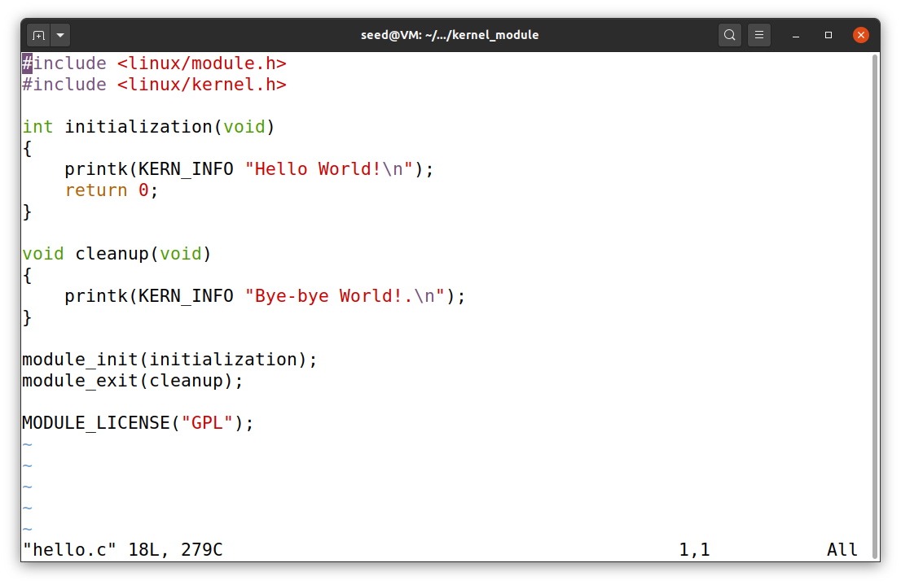In this task we implement a simple kernel module by running the make file and then compile this above hello.c code

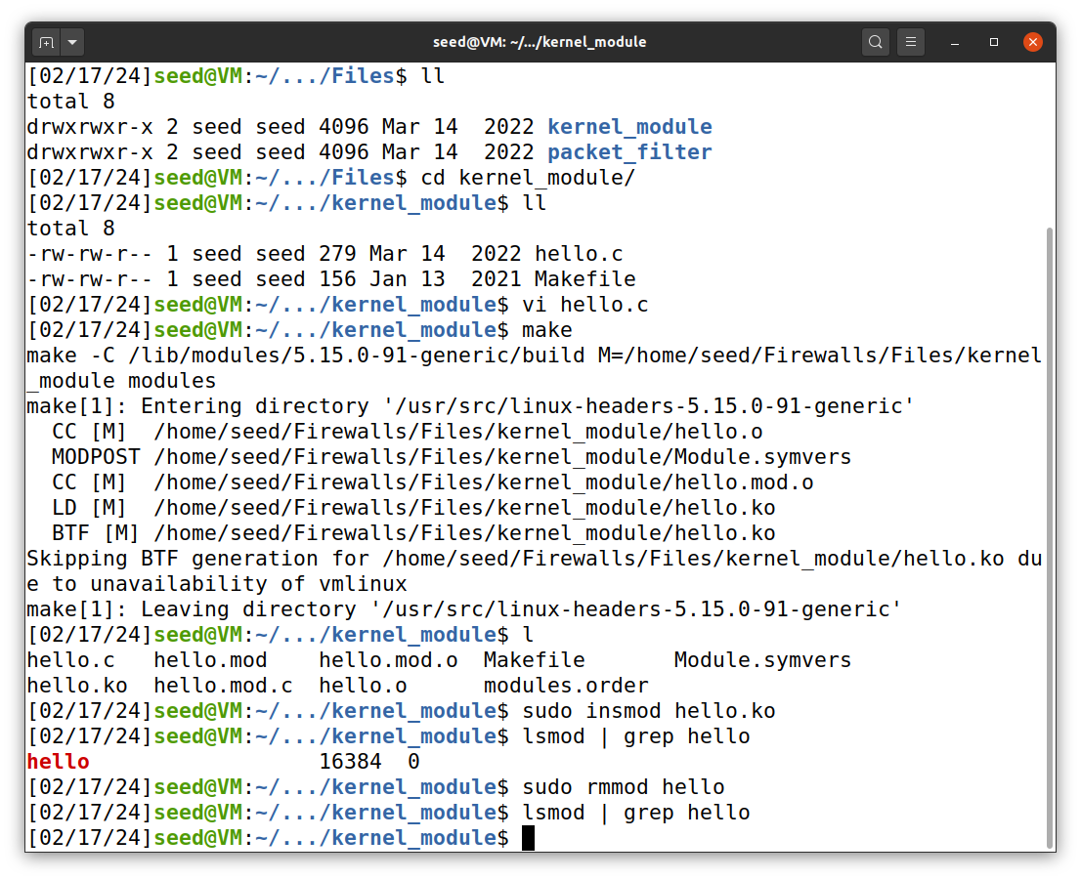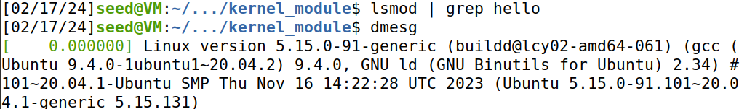So as you can see from the screenshot above I executed as given steps and then the hello kernel model is generated.

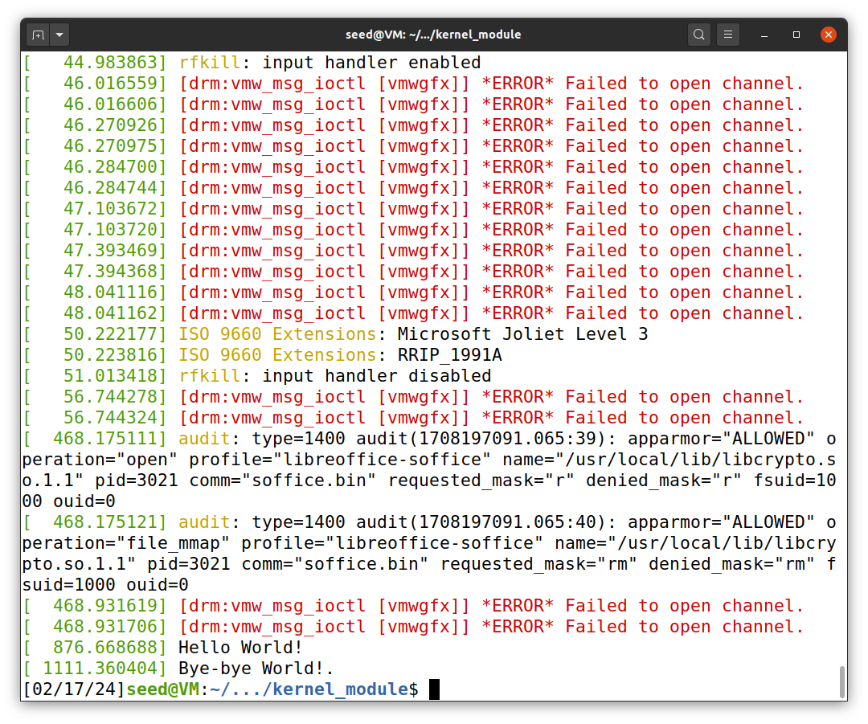

And after I remove the hello module and then execute dmesg statement which printed the statements Hello World! And then Bye-Bye World.

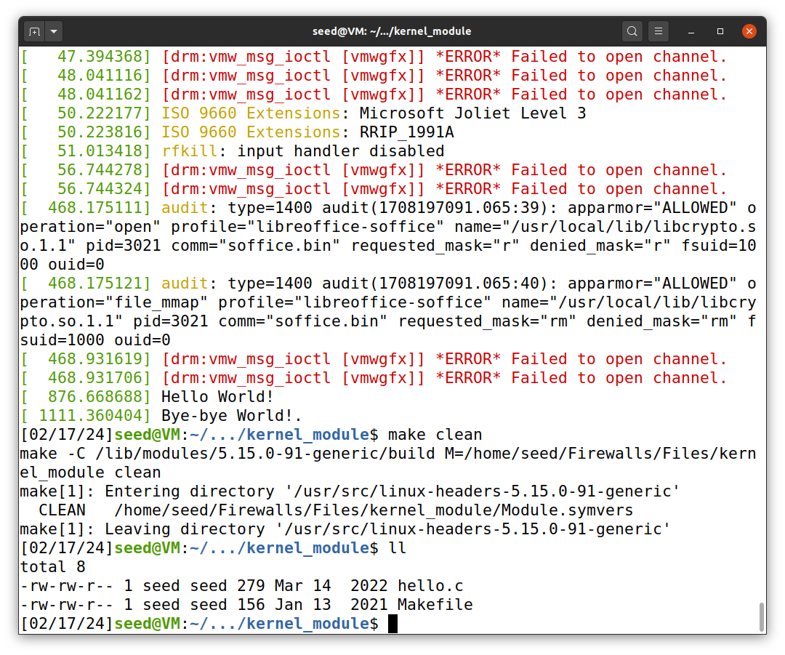

So after executing all the commands then I aslo cleaned the make file, this is that screenshot

**Task 1.B Implement a Simple Firewall using Netfilter**

**Task 1.B 1**

In this task I have implemented simple netfilter by running the code given steps.

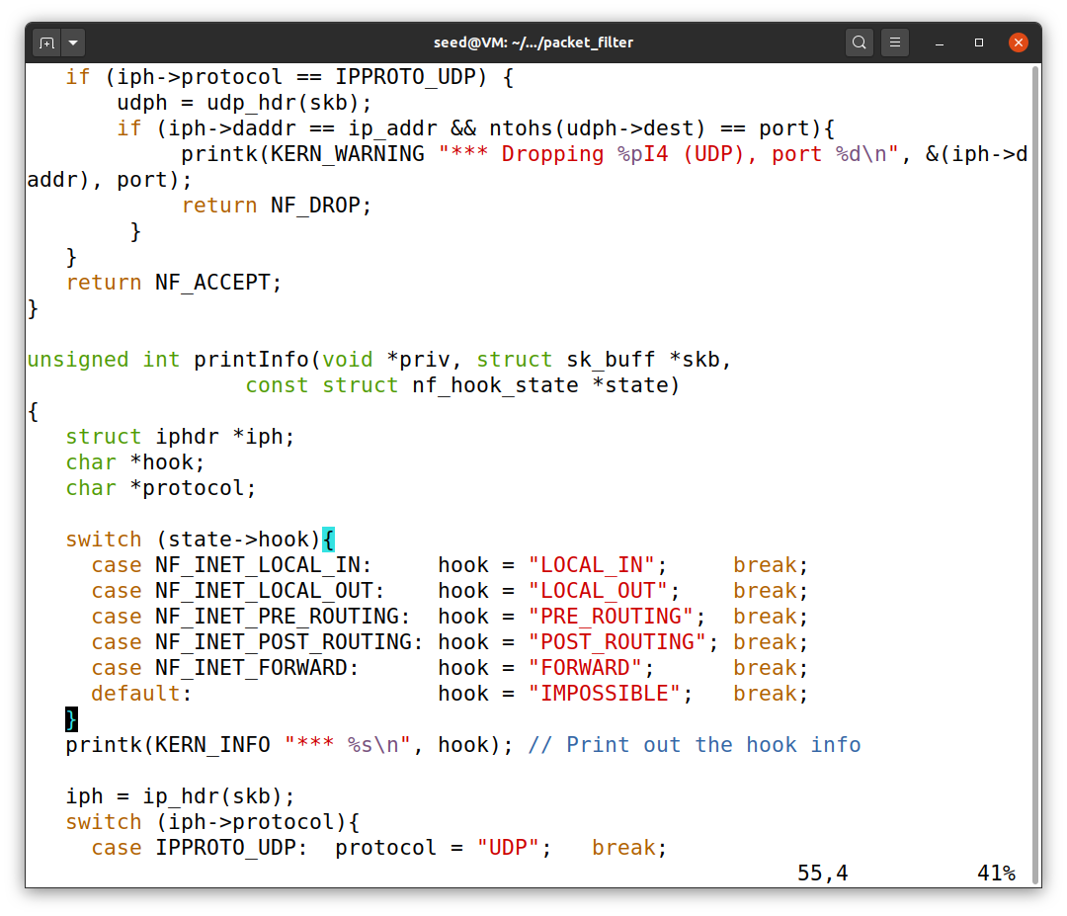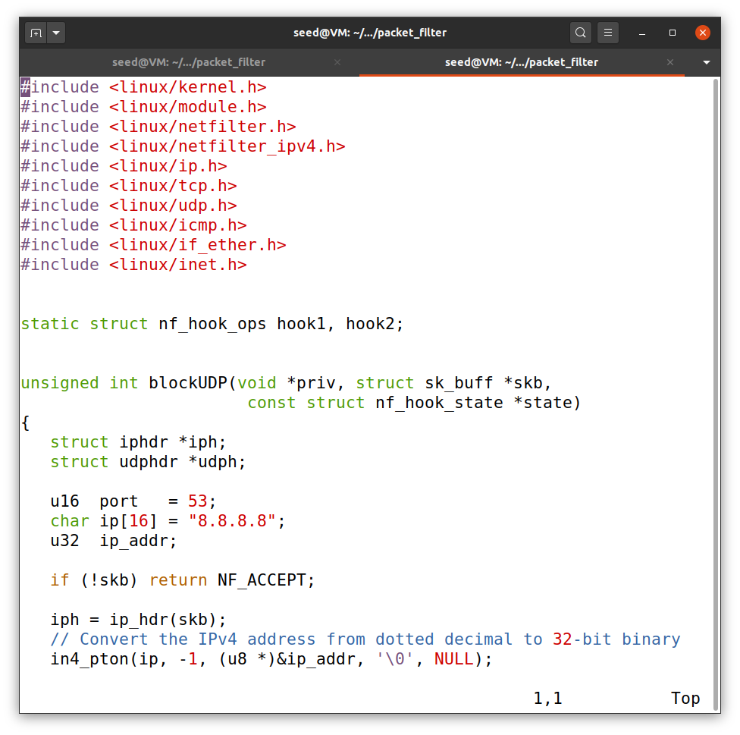

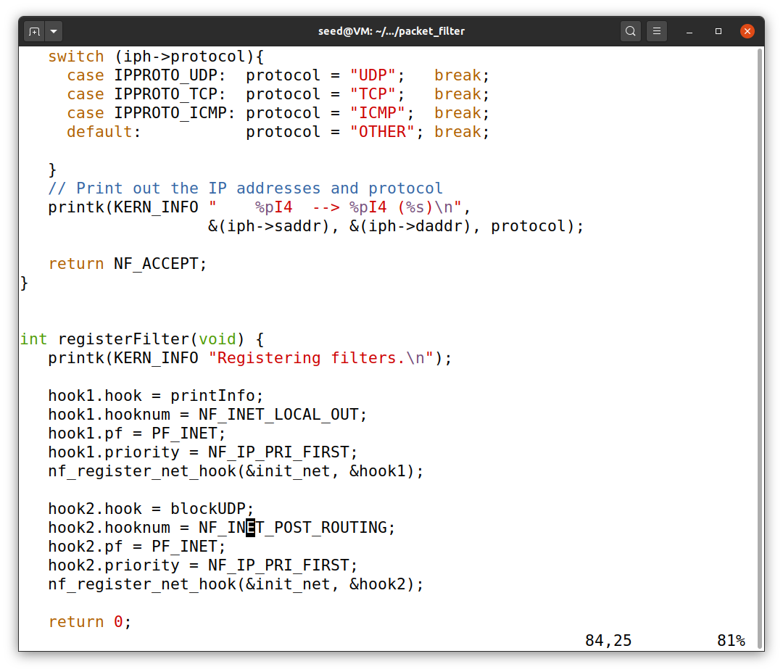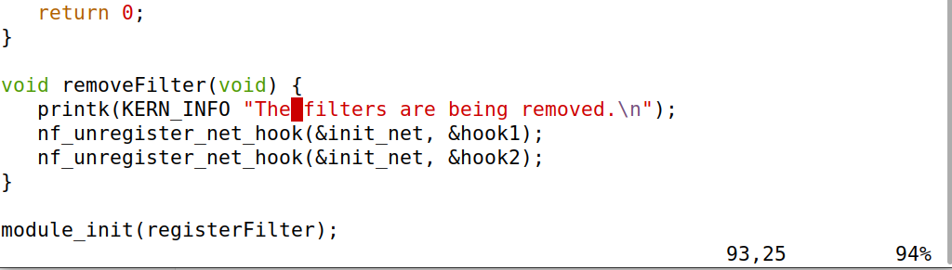

This the netfilter code to execute the code.

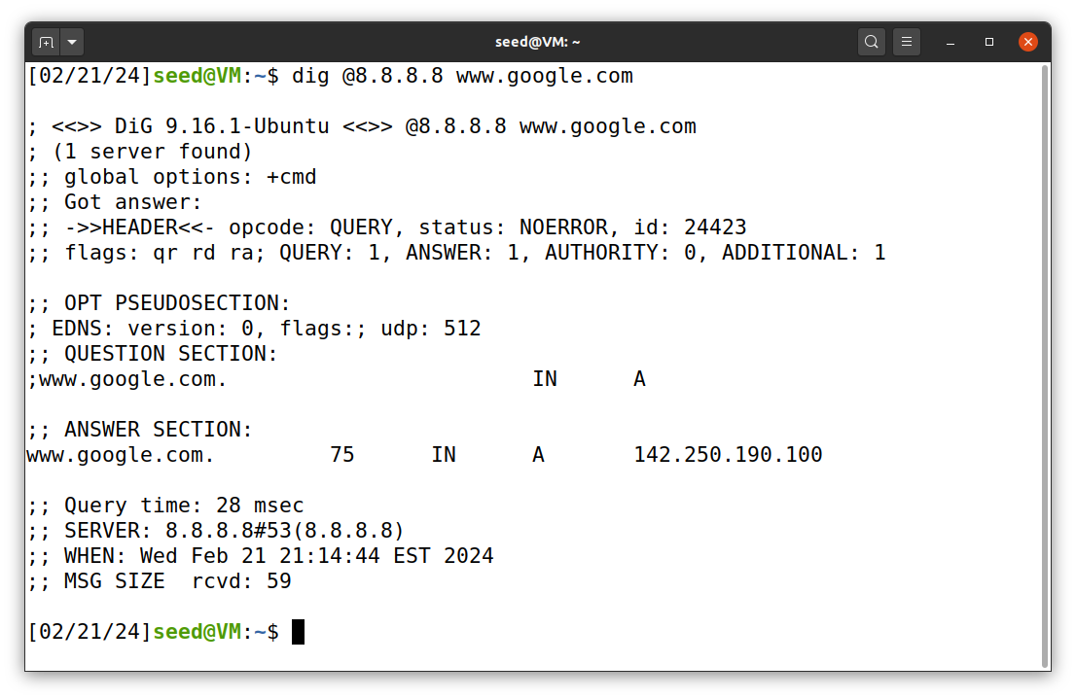

So from the above screenshot as you can see before running the netfilter I can access the google dns.

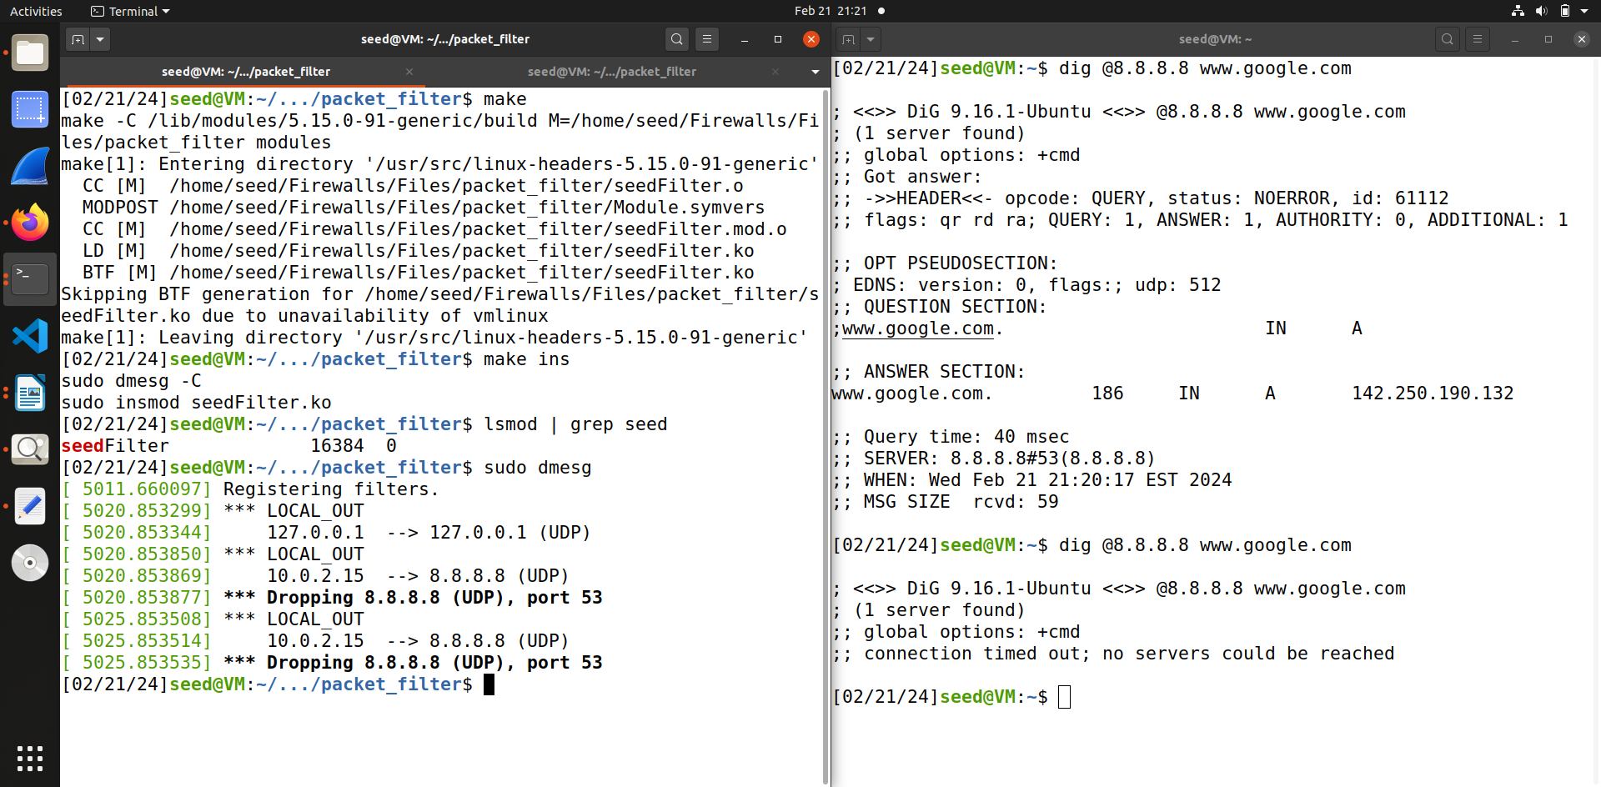 After running the code you can see that google dns is not accessible anymore.

**Task 1.B 2**

In this task I hook the printInfo function to all the netfilter hooks.

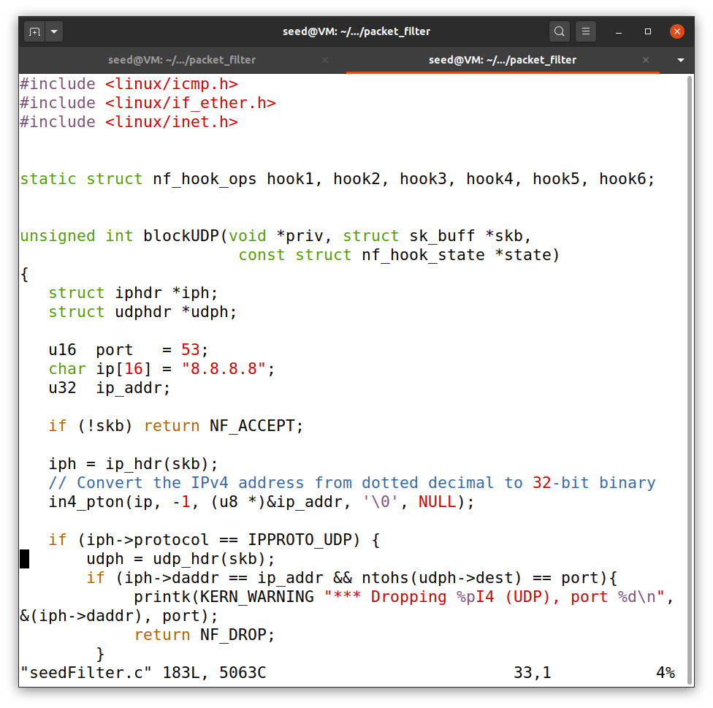

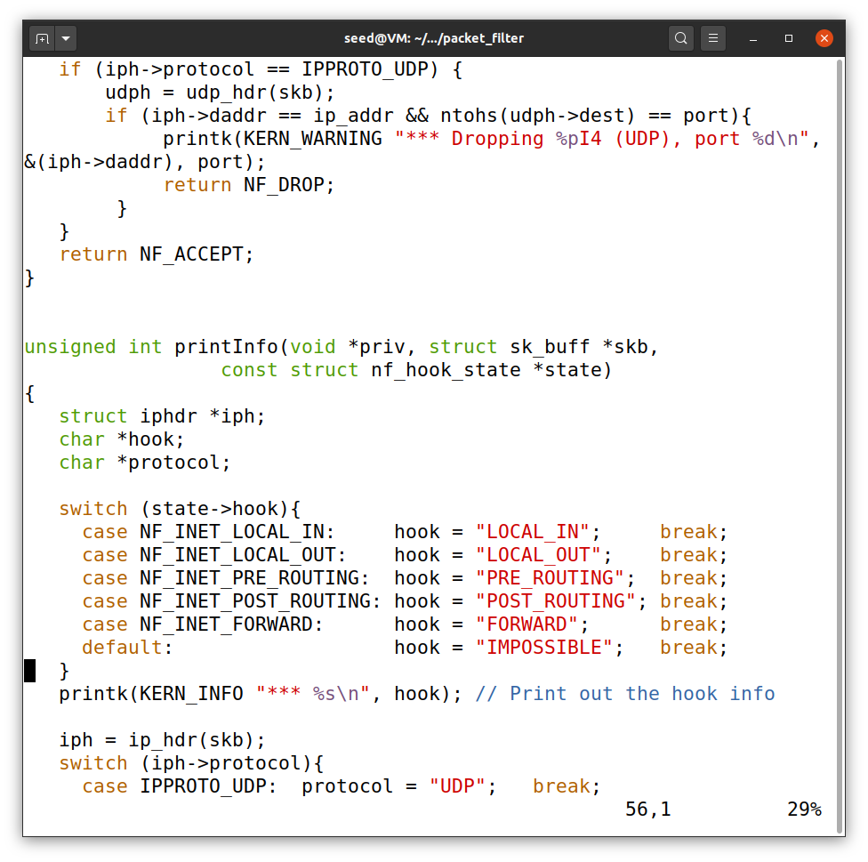

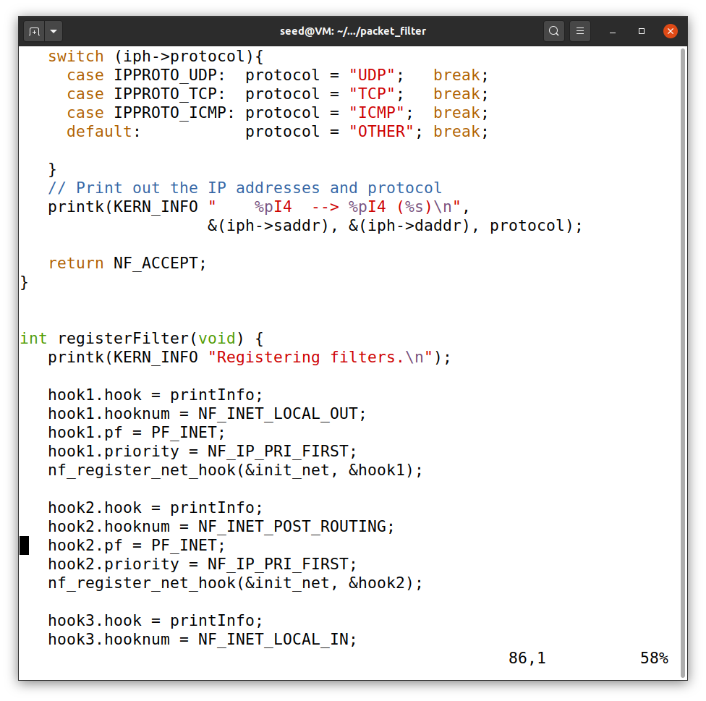

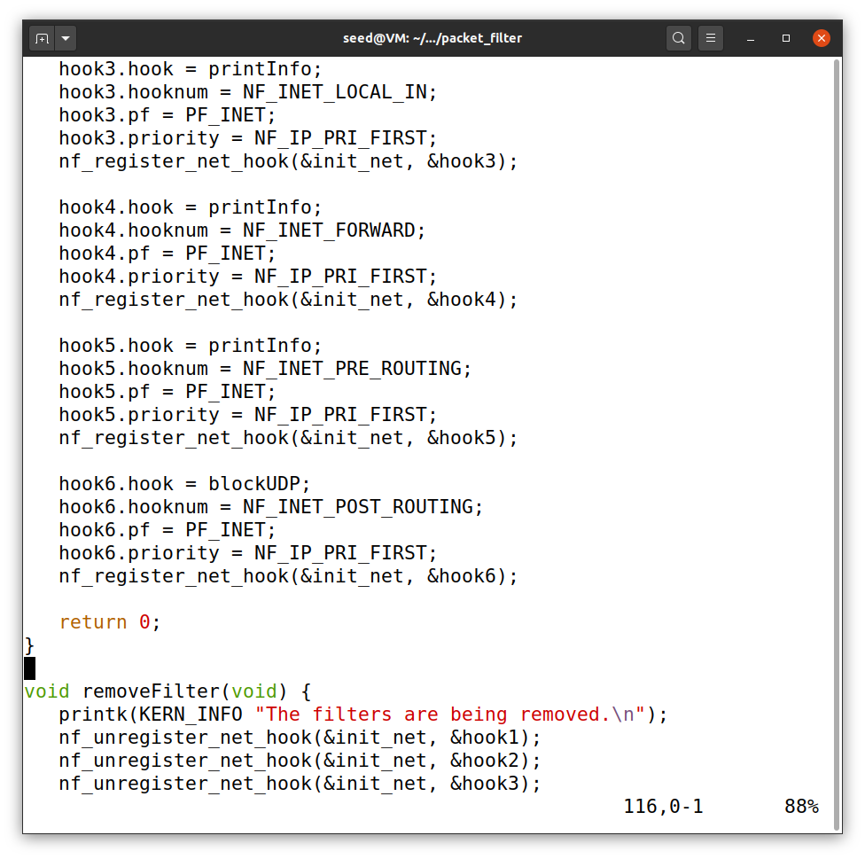

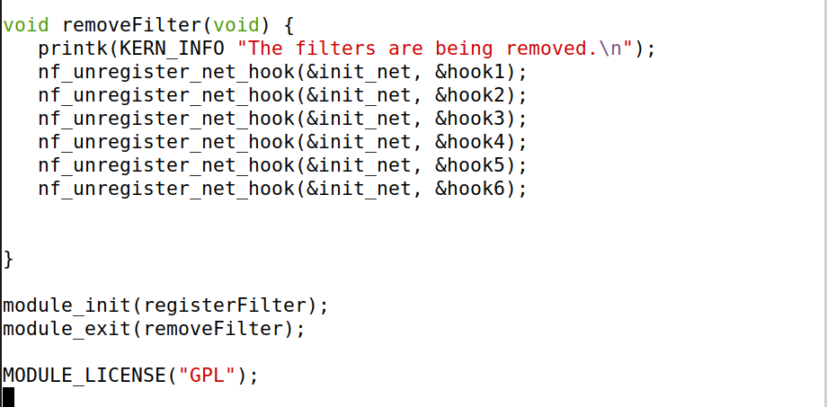

Using this code I have executed all the hooks.

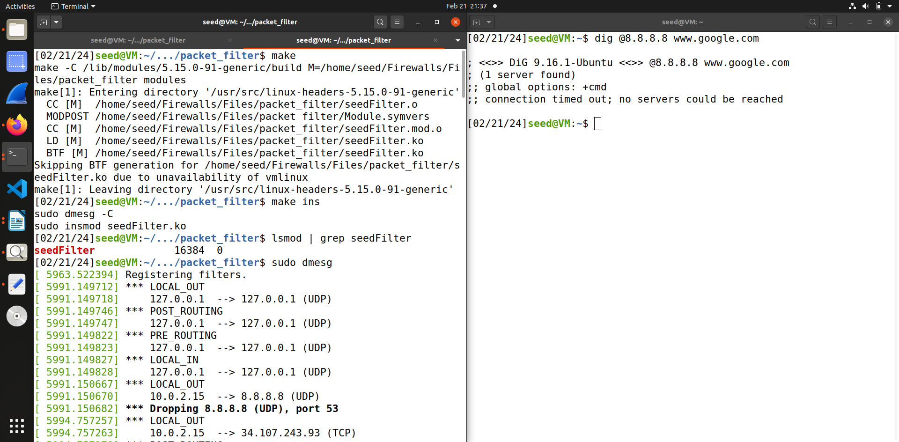

From the above screen shot you can see that the google dns server is blocked and in the dmesg is also printing the 8.8.8.8 has been dropped.

**Task 1.B 3**

In this task we implement two more hooks one to block the ping and the other to prevent the telnet

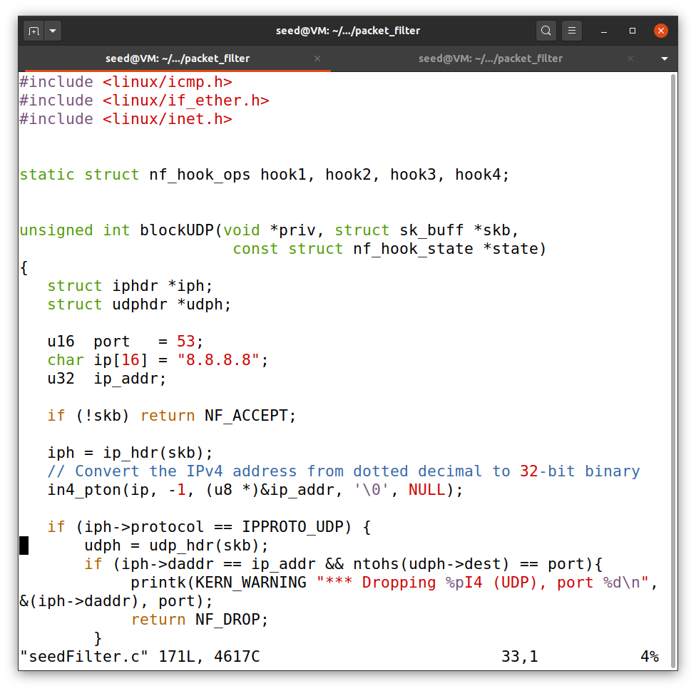

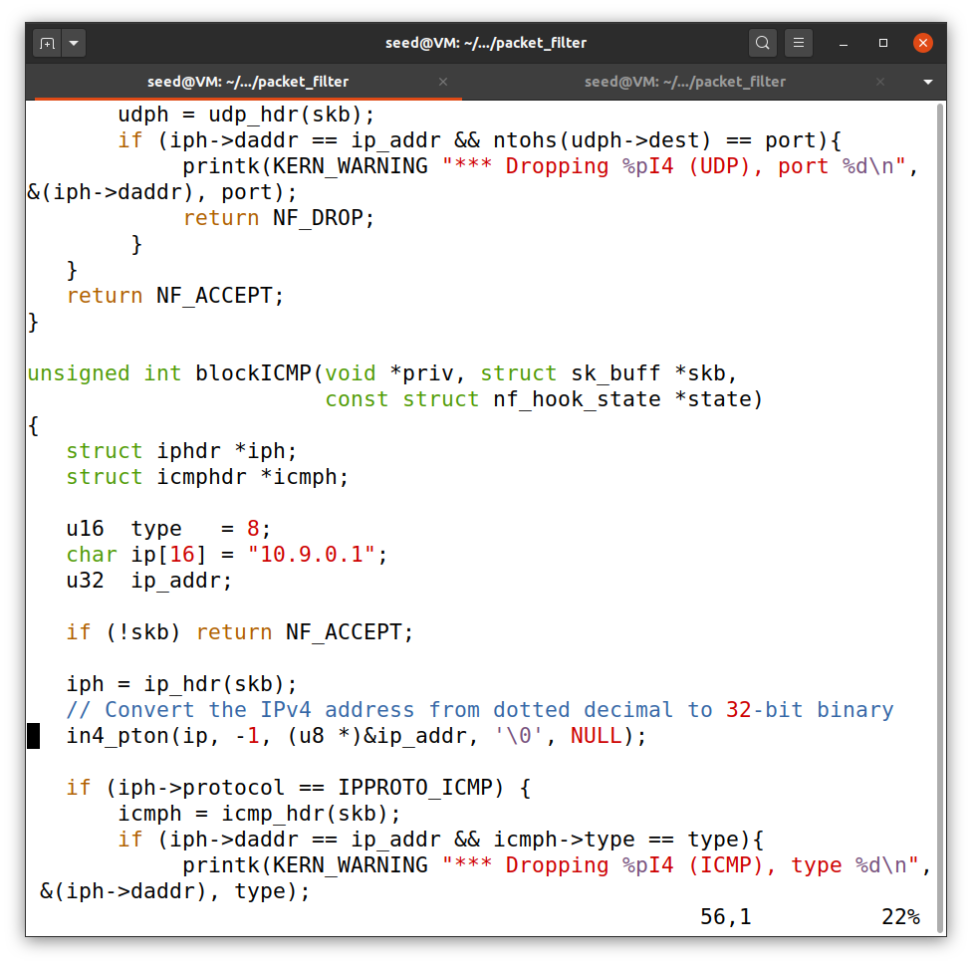

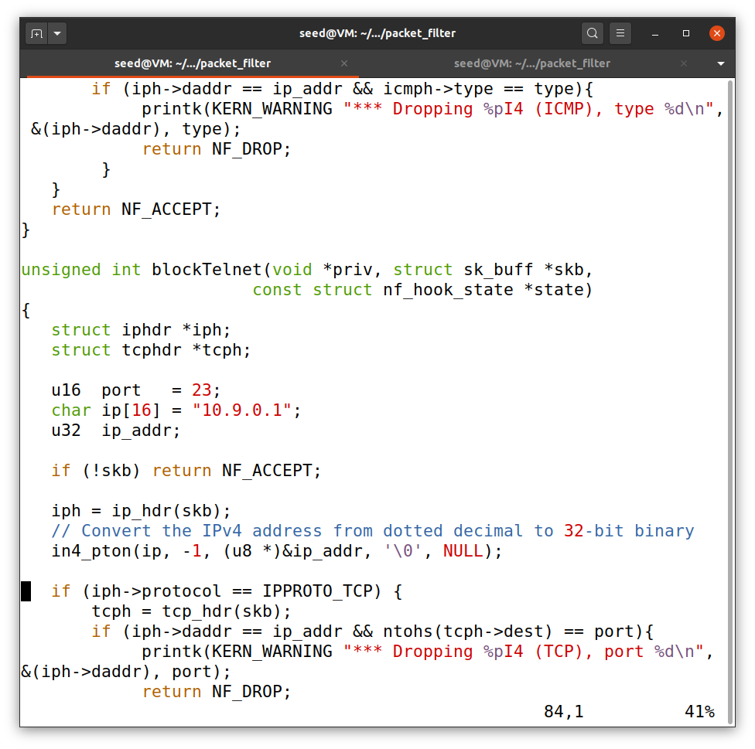

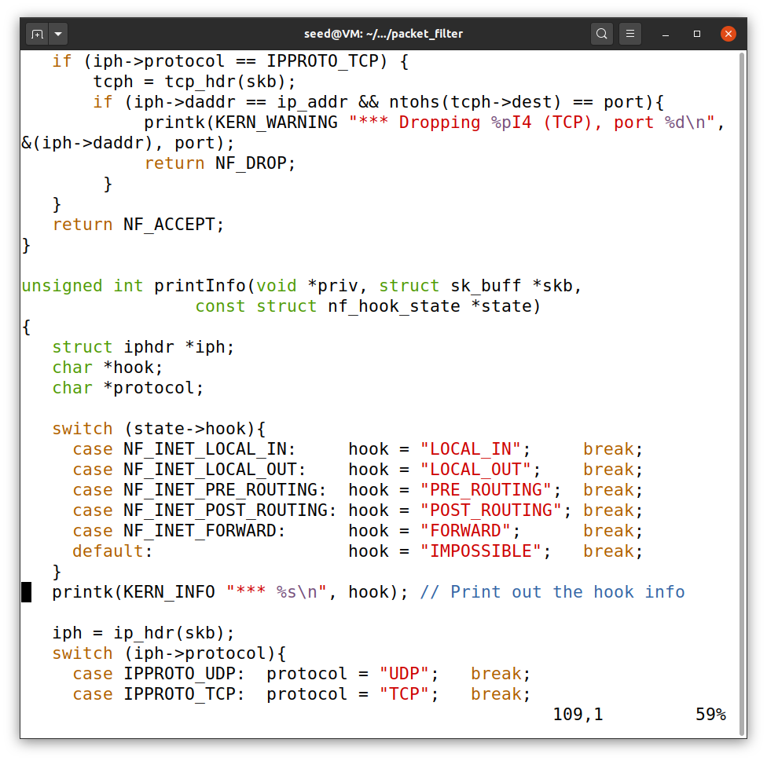

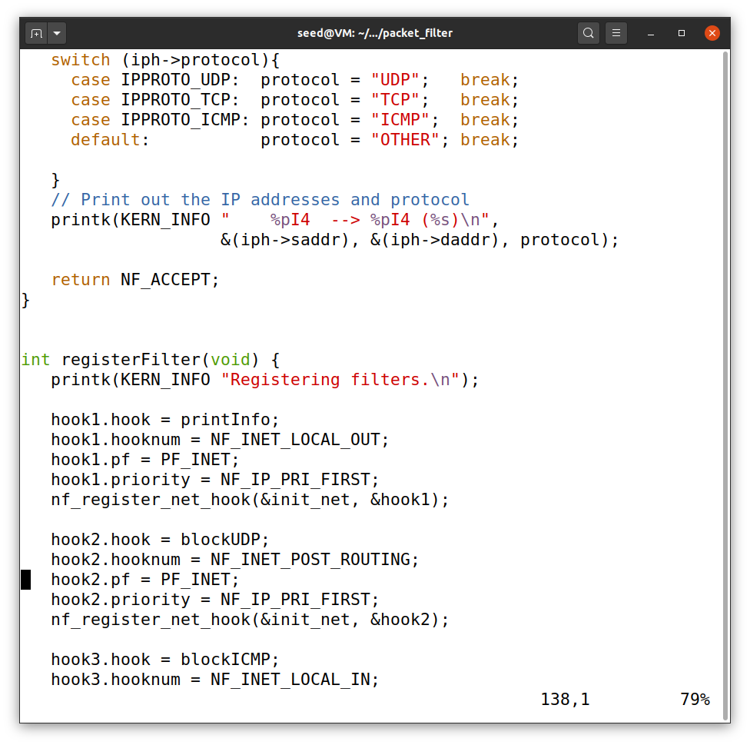

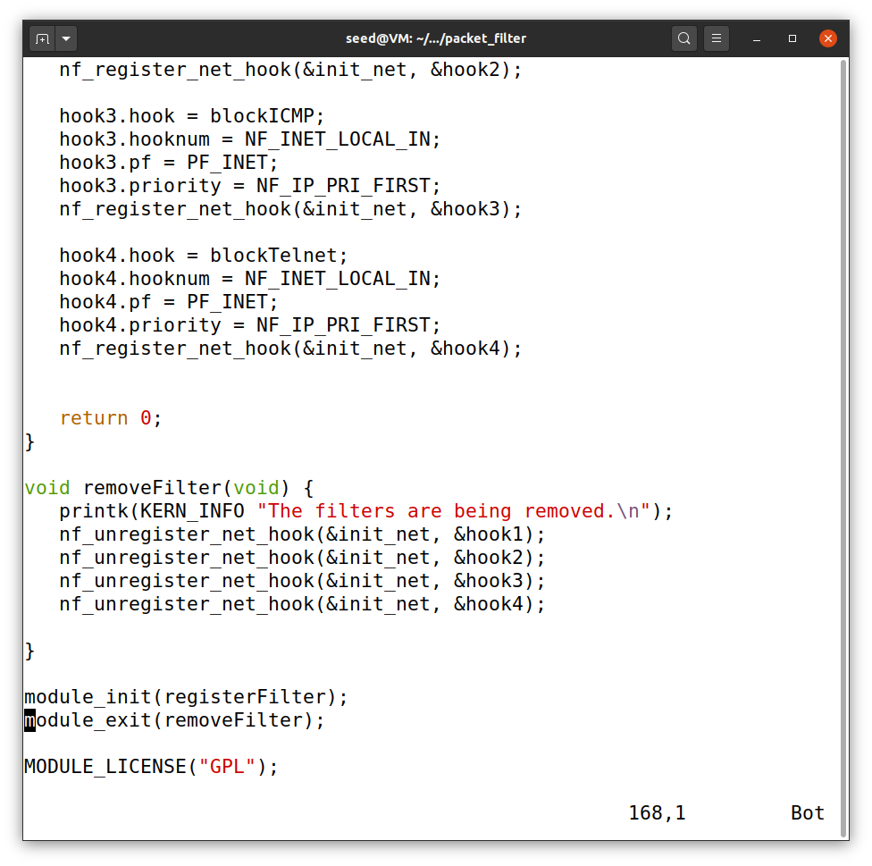

So this the code to execute the task.

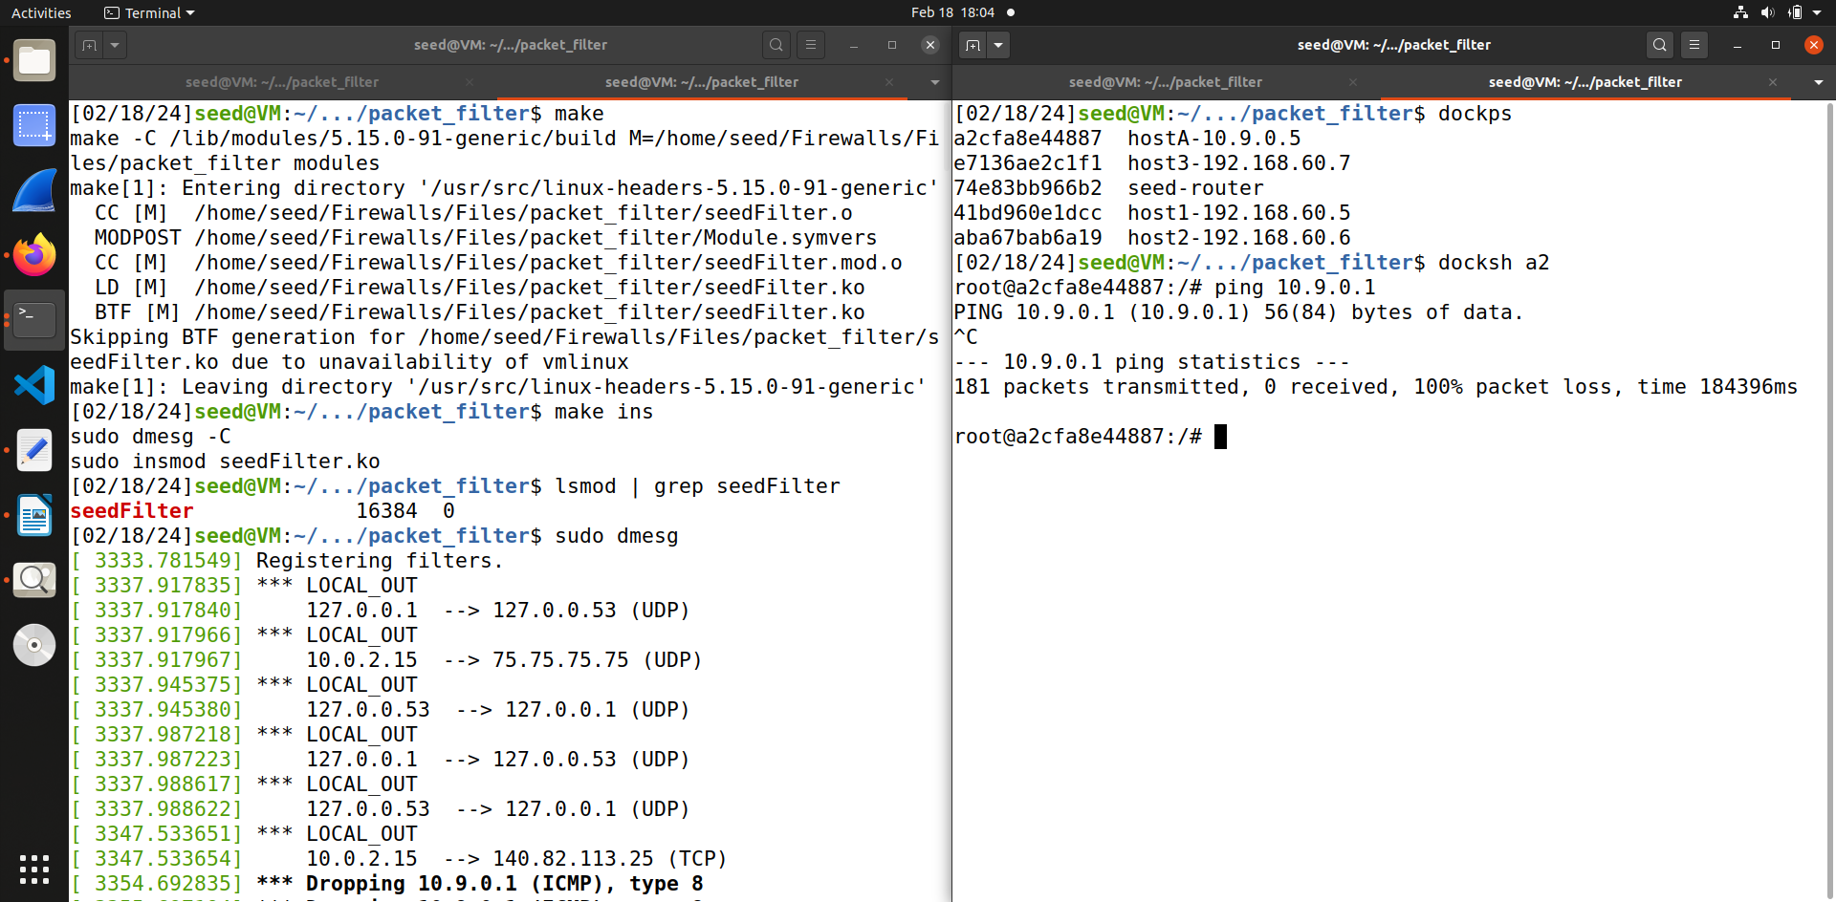

So as you can see from the screen shot 10.9.0.5 is not able to ping 10.9.0.1

And it is also visible in sudo dmesg.

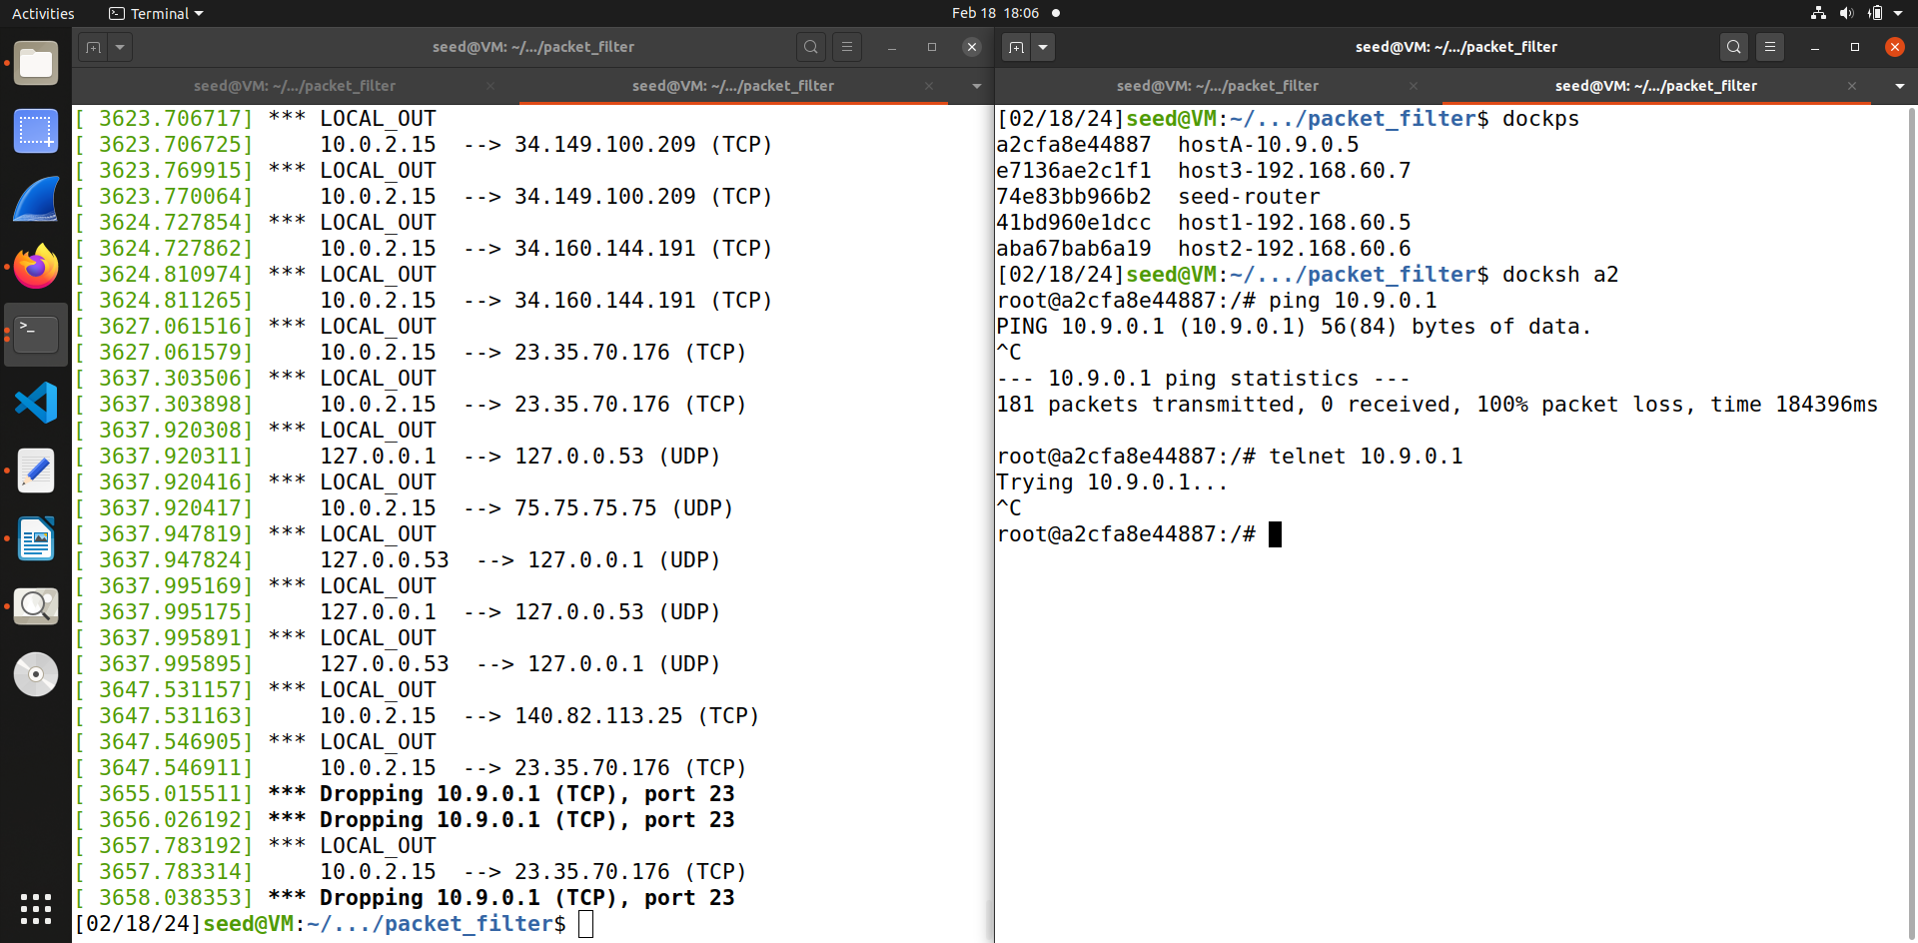

And similarly is is not able to telnet to 10.9.0.1

**Task 2**

**Task 2.A : Protecting the Router**

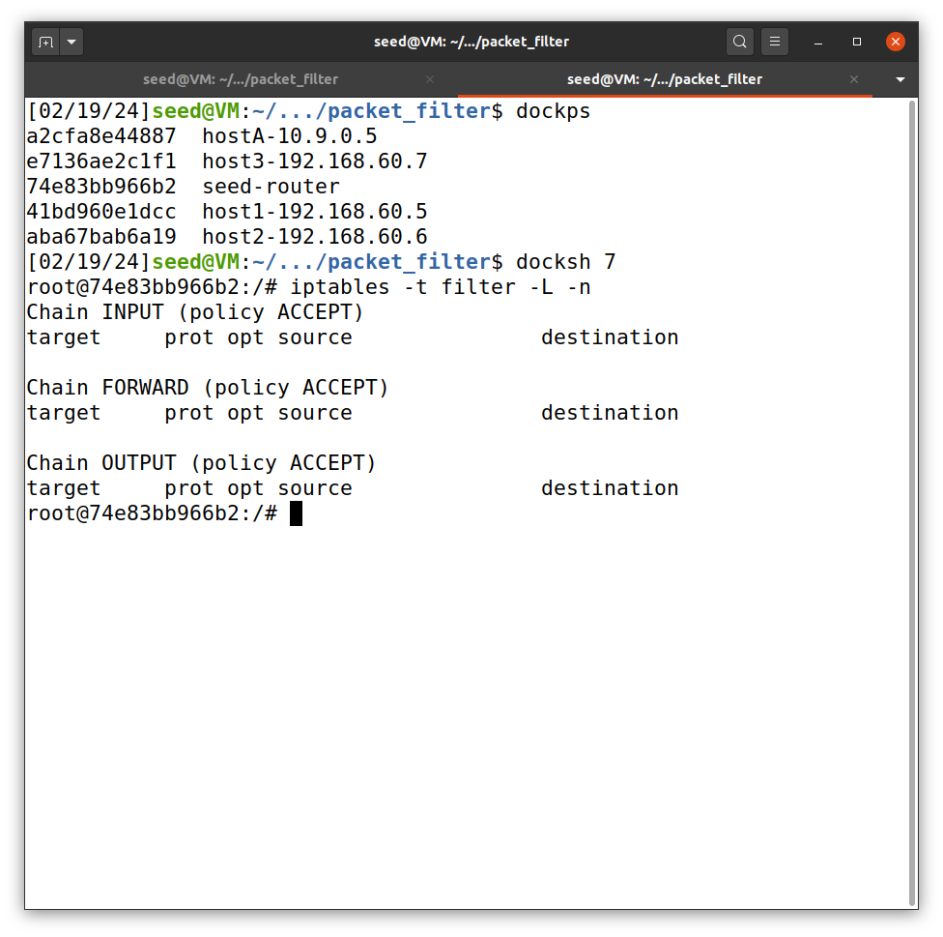

So this is where we can see the rules when we use iptables to set new rules. Currently it is empty.

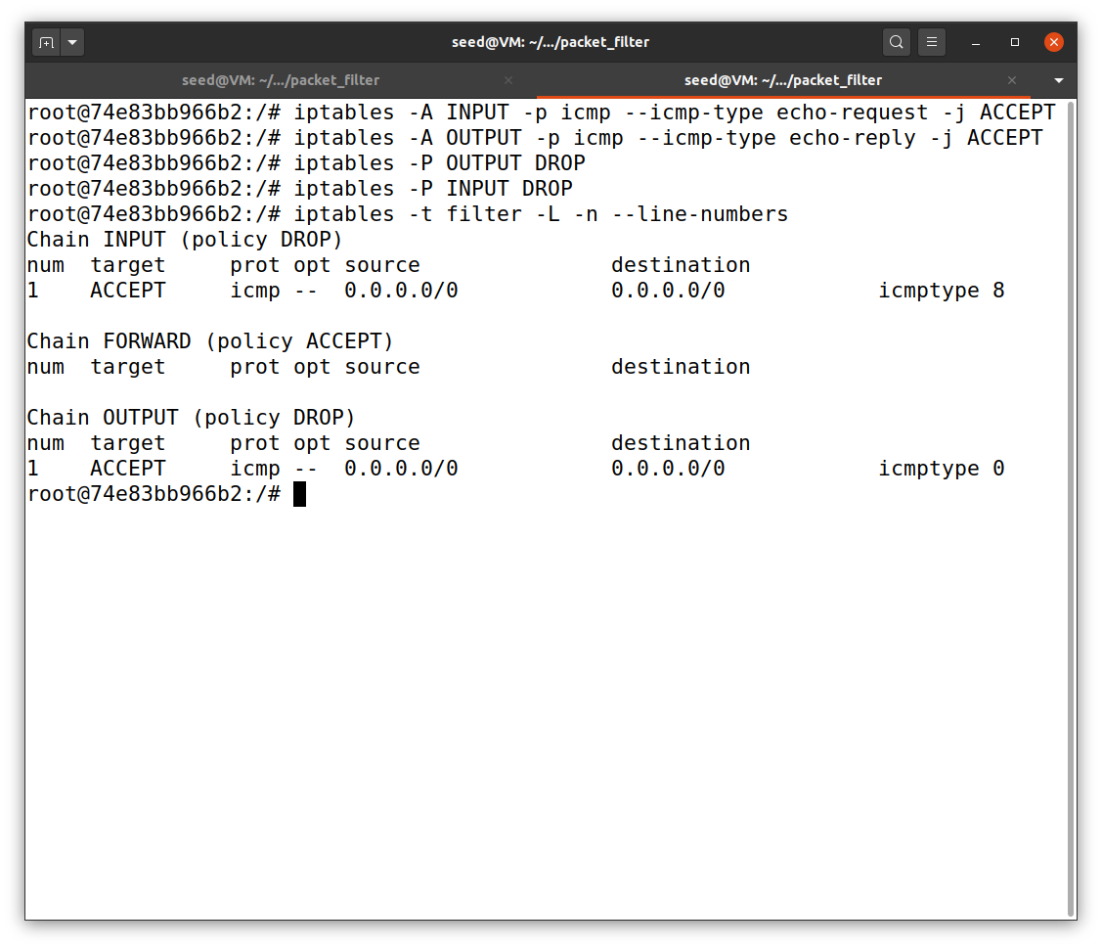

Now I added the new rules and as you can see from the above screenshot it is visible when we check the table

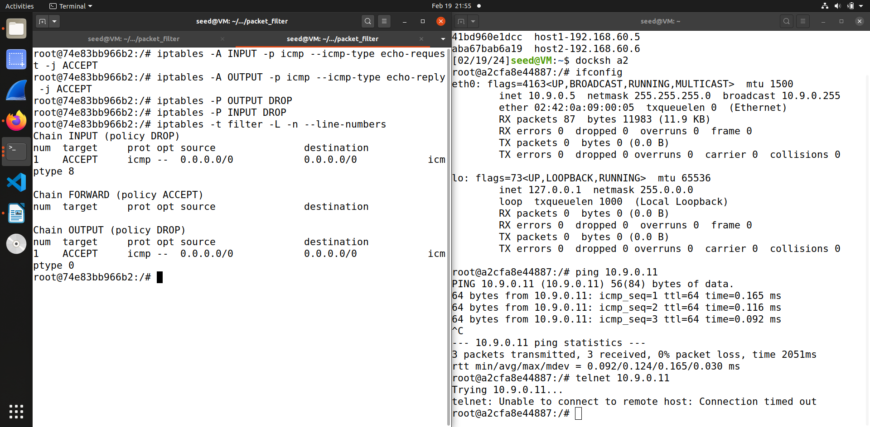

As yo can see from the screenshot if we tried to ping 10.9.0.11 we are able to do that, but if we try to telnet 10.9.0.11 it is not connecting, this shows that the firewall is working.

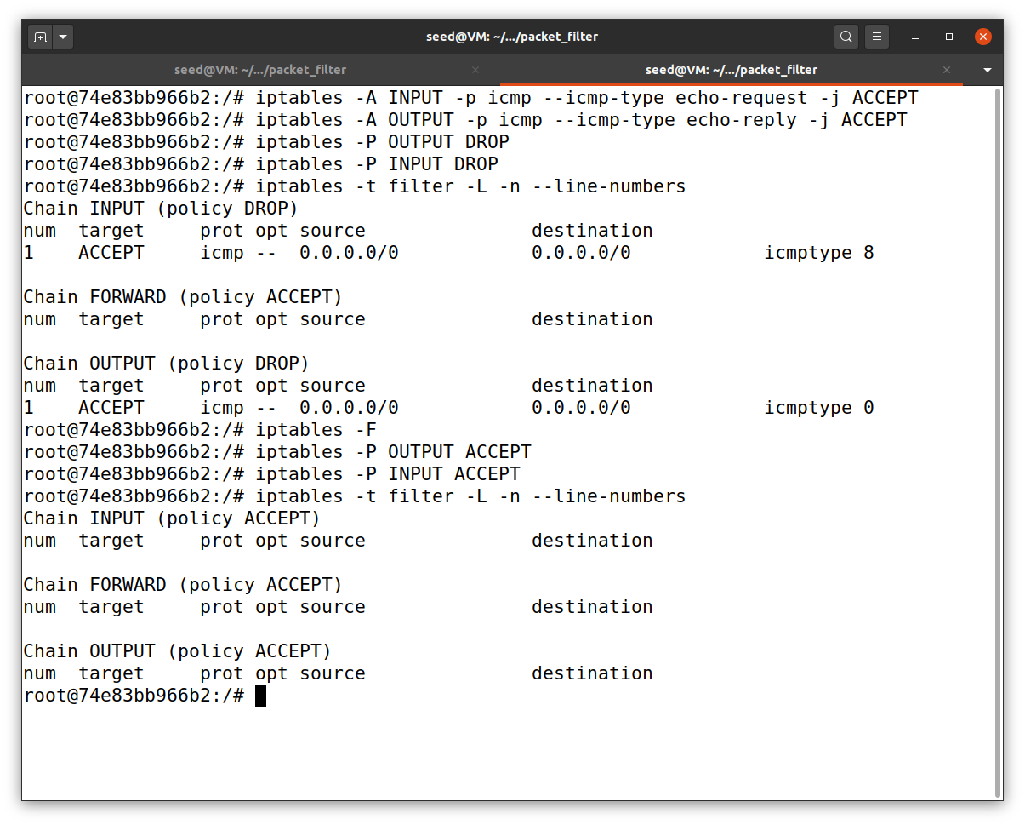

So before executing the next task it is important to clear the tables by removing all the rules.

**Task 2.B: Protecting the Internal Network**

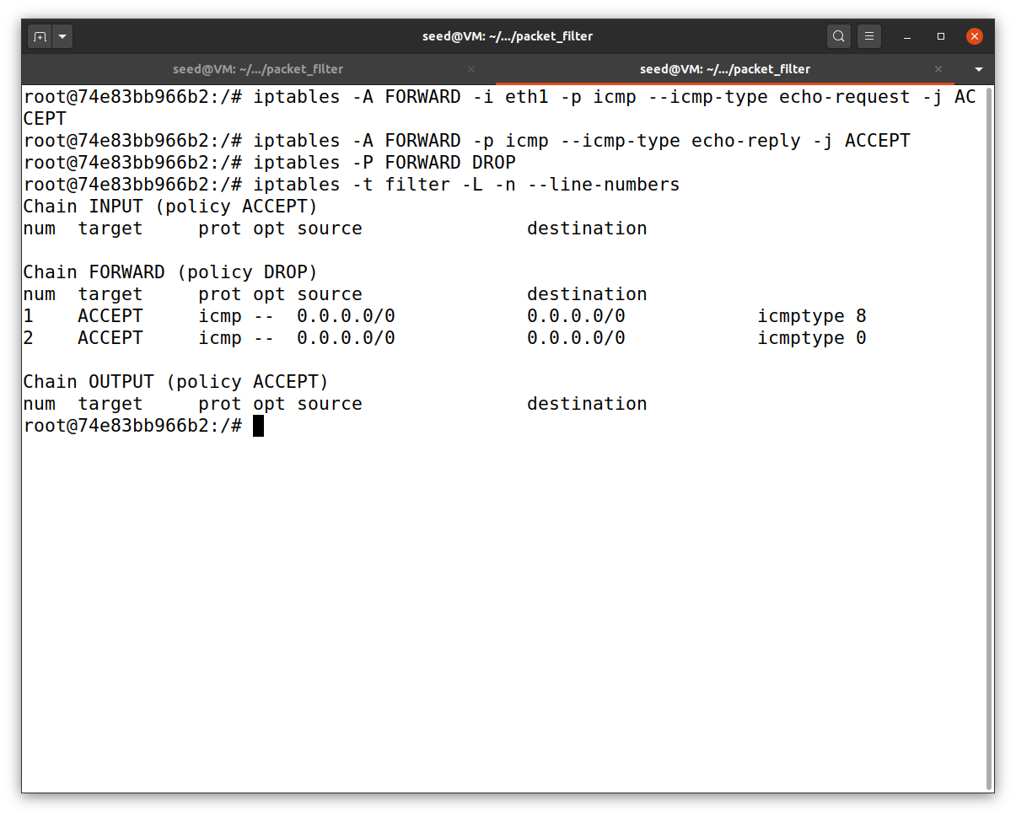In this task we setup firewall rules to protect the internal network 192.168.60.0/24. Above are the rules I added.

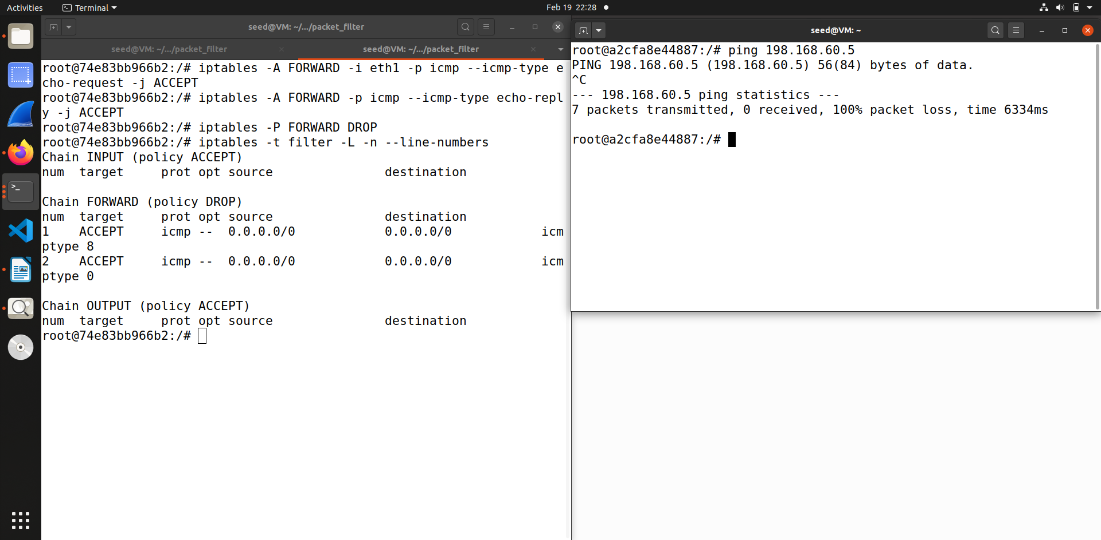So when we try to ping the network from outside that is host A then the ping fails.

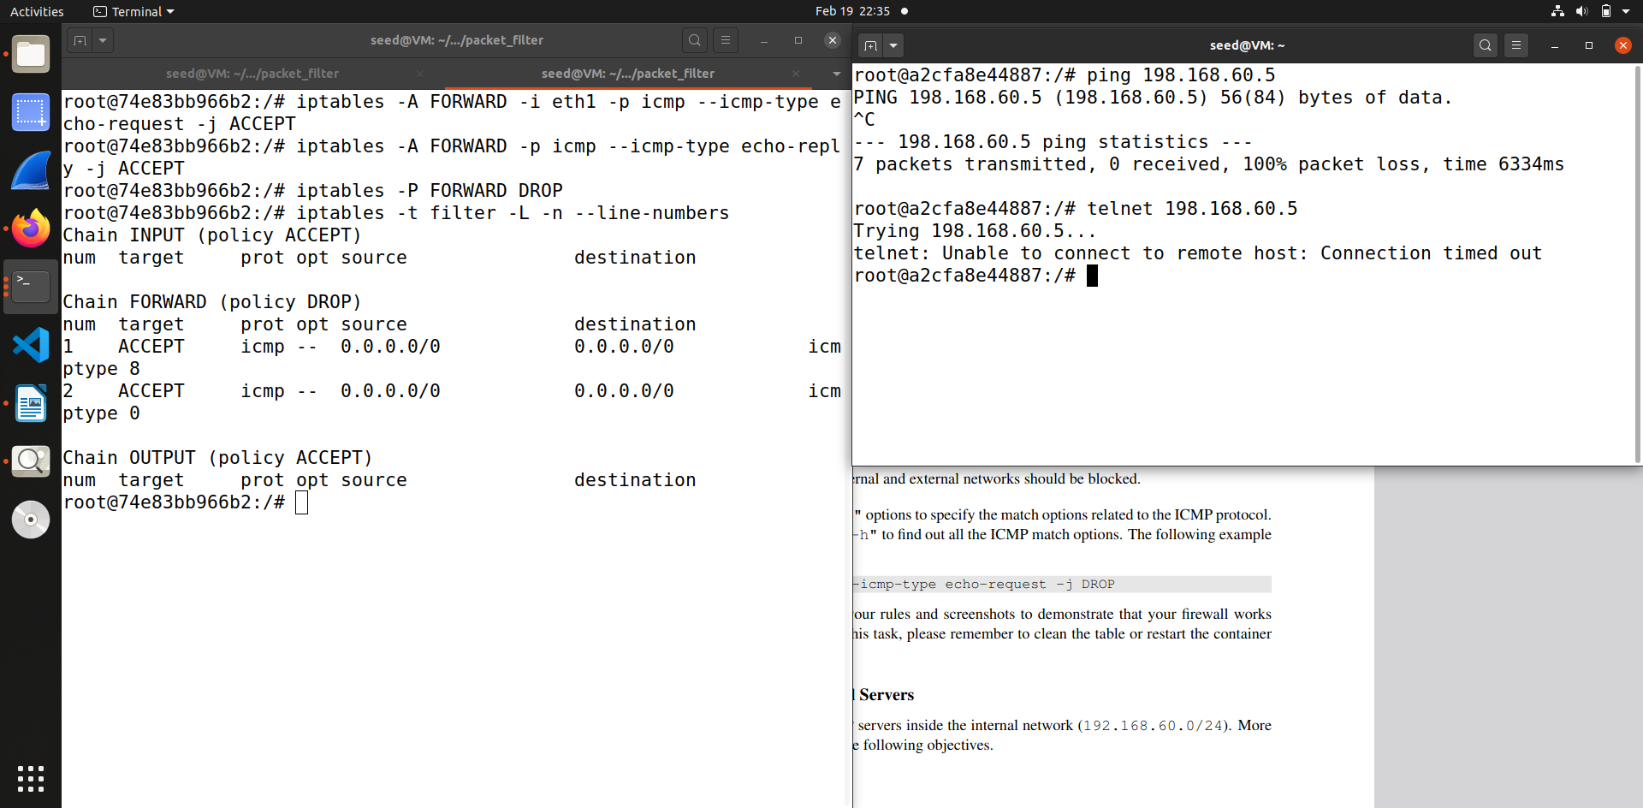

When I try to telnet from outside this fails, this shows that the firewall is working

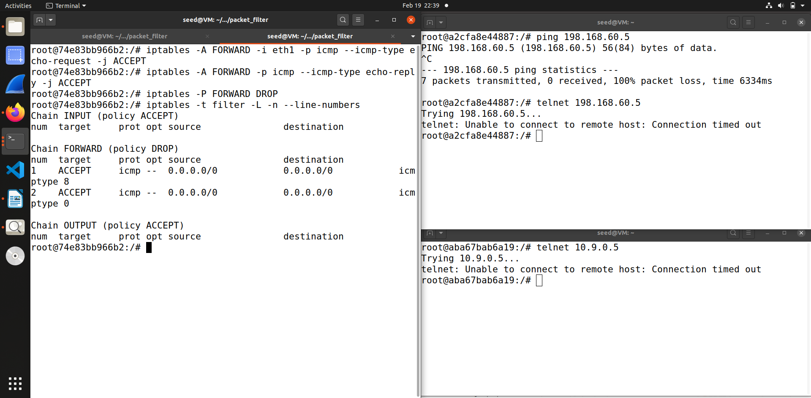When I try to ping 10.9.0.5 from inside this also fails, so internal and external network connection is also closed.

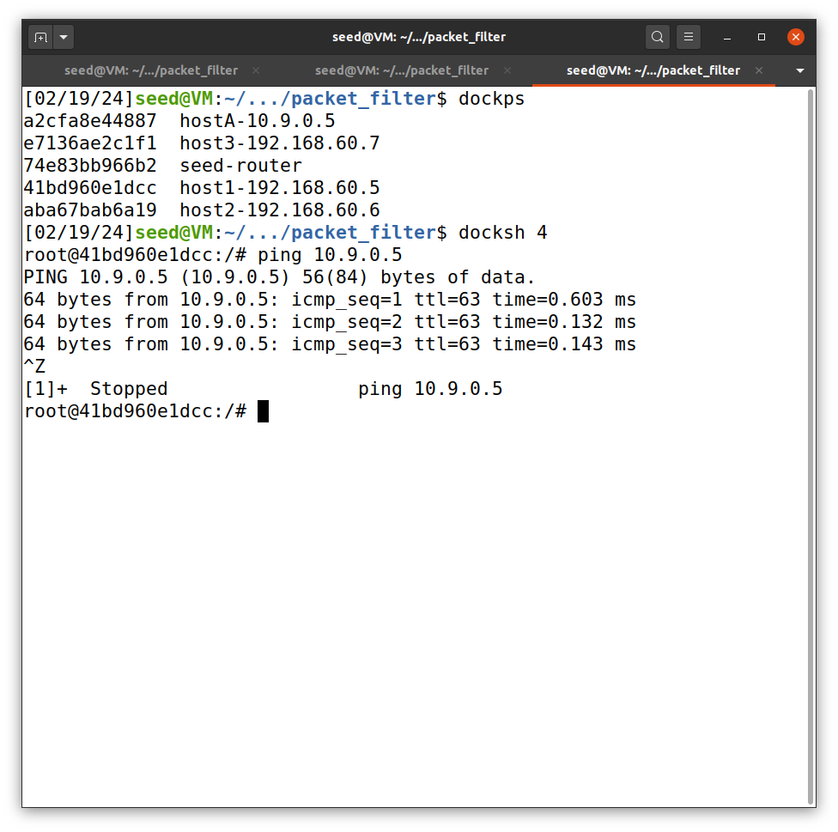But Internal hosts can ping outside hosts as shown from the screenshot.

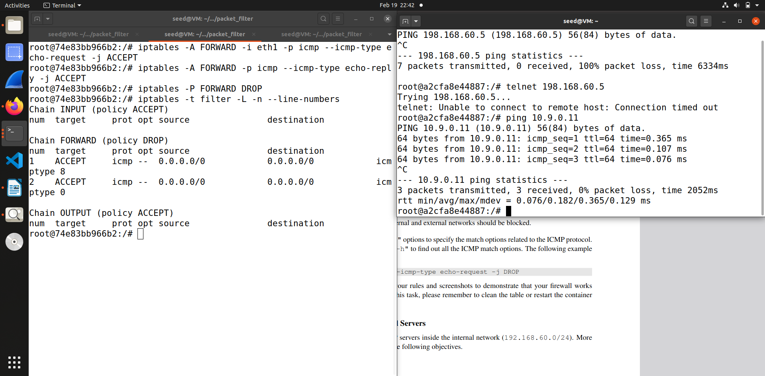We can also ping the router because we didn’t add any rule for that.

**Task 2.C : Protecting Internal Servers**

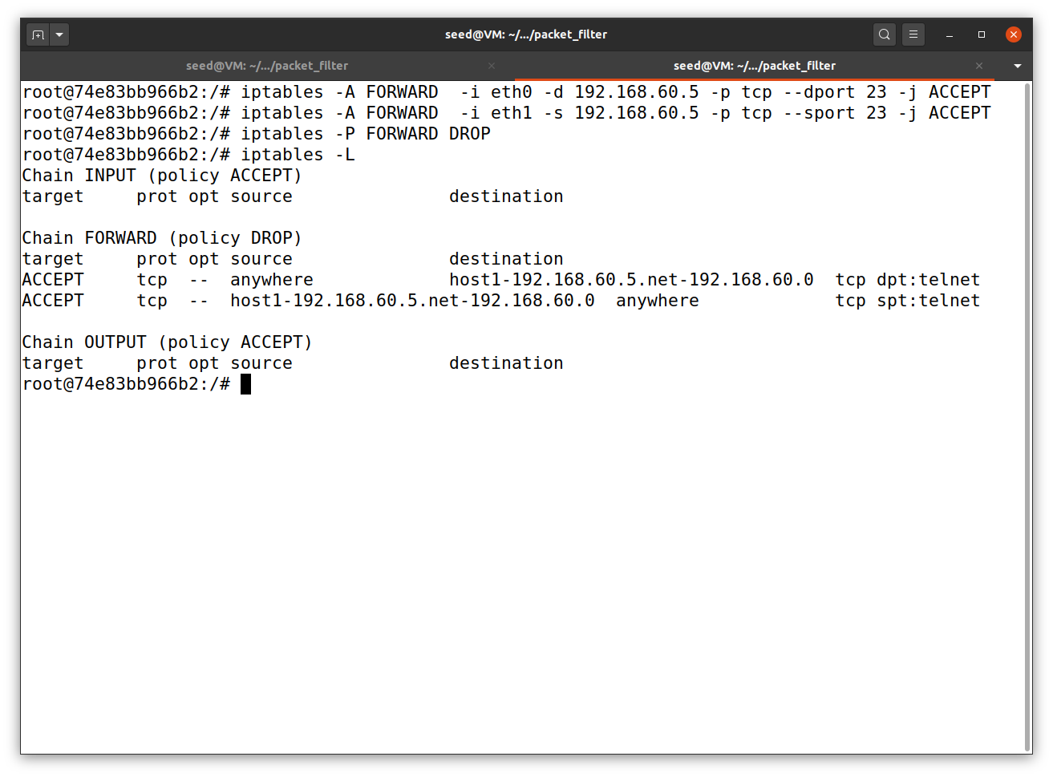

In this task we set up rules to protect the TCP servers inside the internal networks by only allowing TCP packets to 192.168.60.5 and dropping all others. So these are the rules for that.

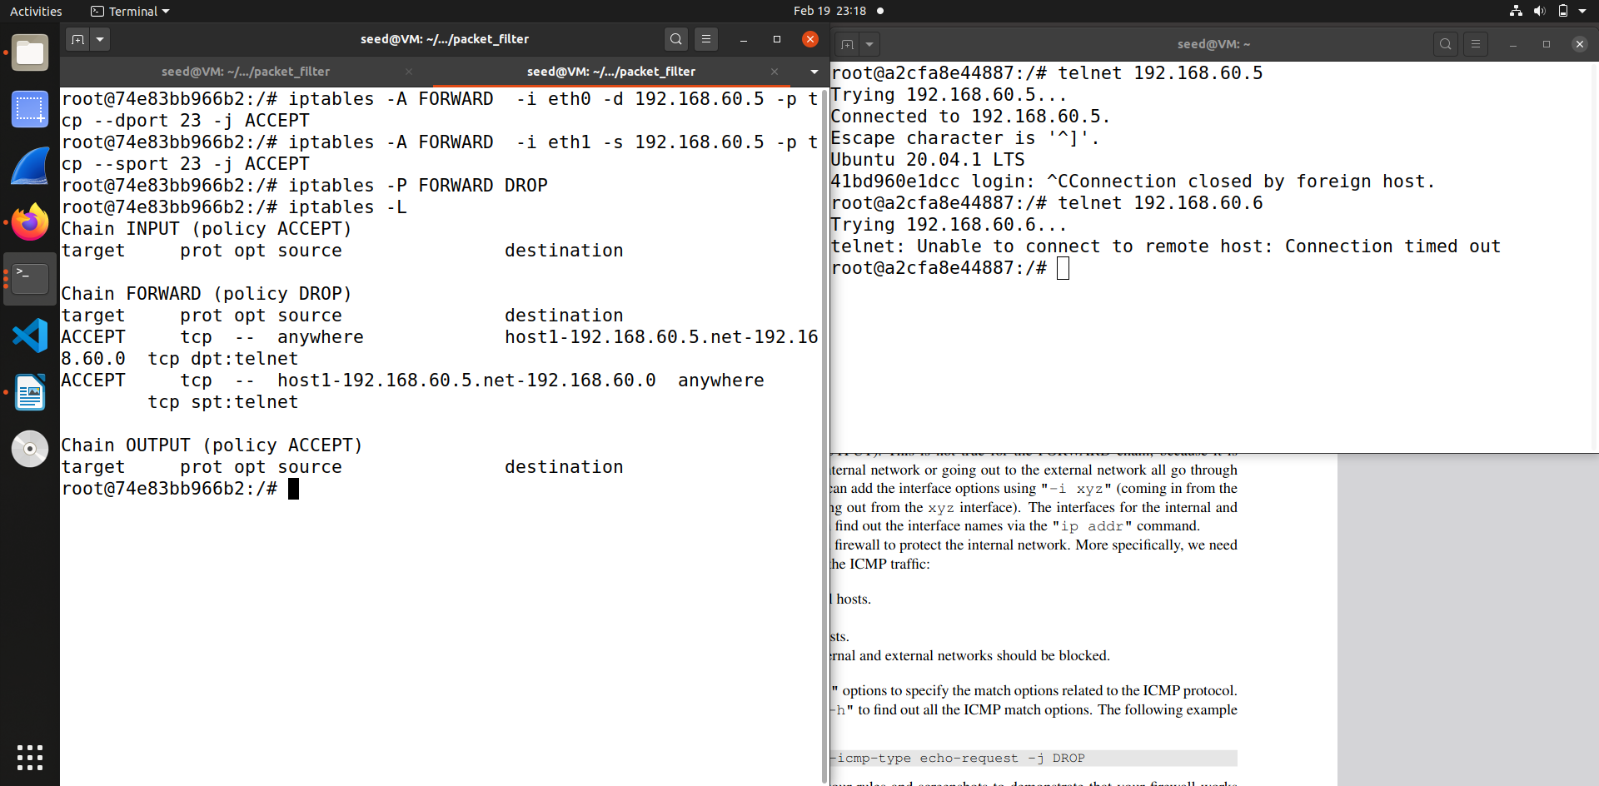

So we have only allowed outside hosts to access 192.168.60.5 , so we can telnet from 10.9.0.5 which is outside. In this screenshot you can see I have canceled the connection but it was successful.

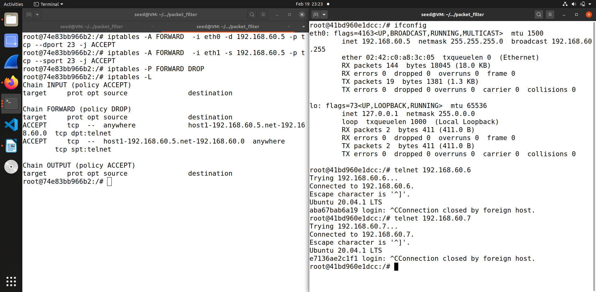When we telnet inside network it is possible.

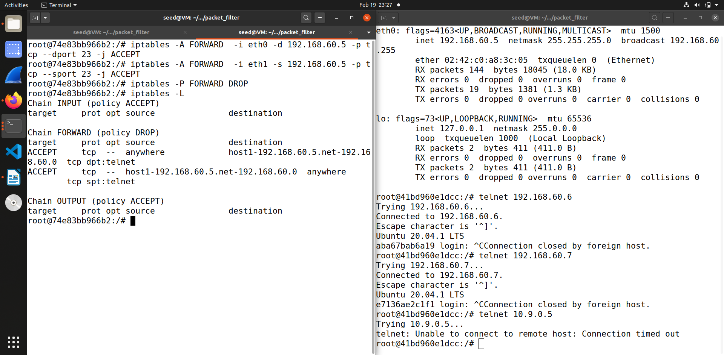When we try to connect to outside network that is 10.9.0.5 it is not possible. Thus the internal servers are protected.

**Task 3**

**Task 3.A : Experiment with Connection Tracking**

**1 ICMP Experiment**

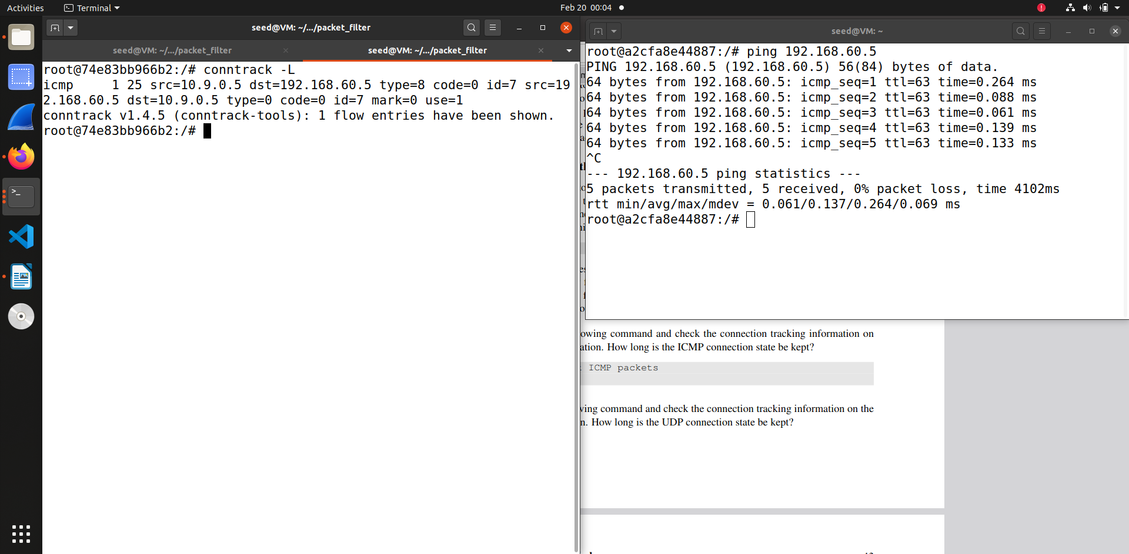

In this we ping from external host to check the conntrack mechanism.

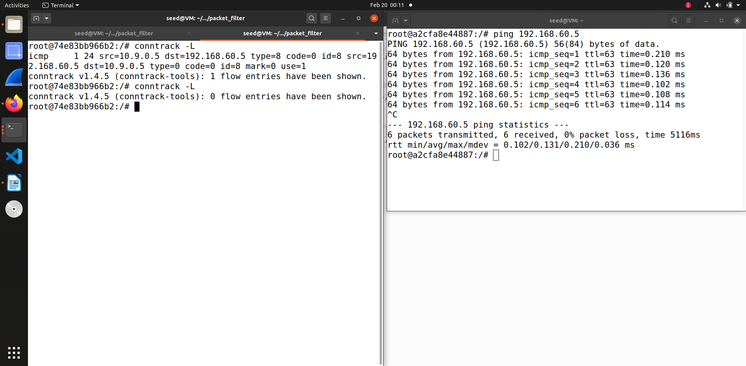

Looking at the conntrack connection for ICMP experiment on the router. For me the entry is for 30 seconds or so. As you can see as it is not visible , as it is there for very short period of time.

**2 UDP Experiment**

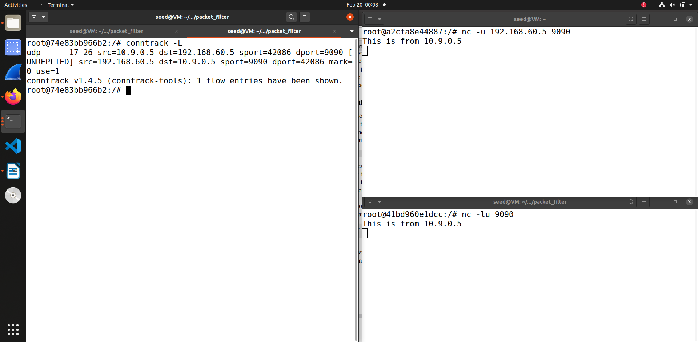

In this I have used netcat to send UDP packet for conntrack mechanism

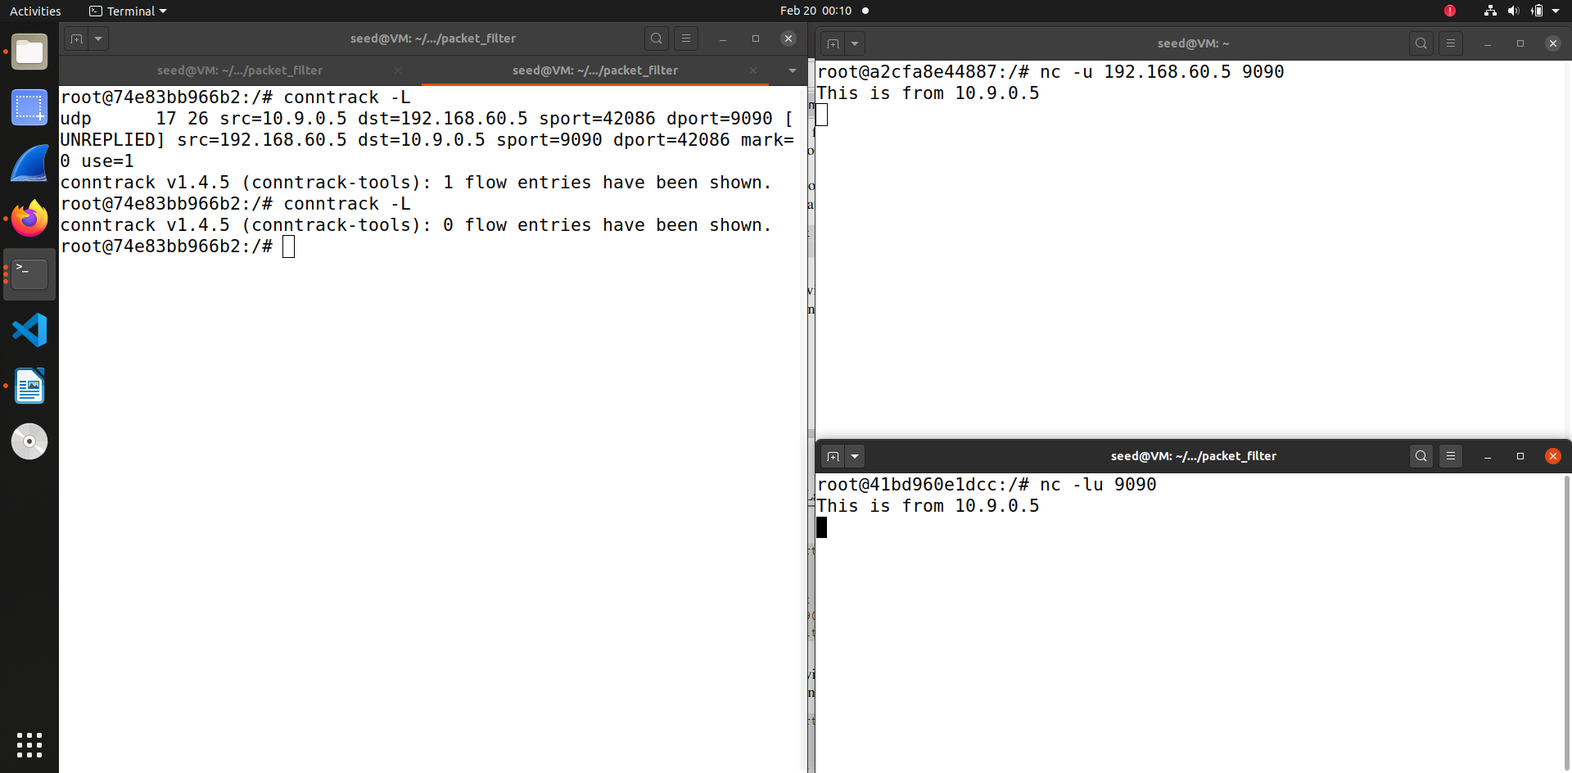For the UDP experiment of conntrack it is quite similar to the ICMP experiment and as you can see the flow of entry is kept for very short period of time, like 30 seconds or such.

**3 TCP Experiment**

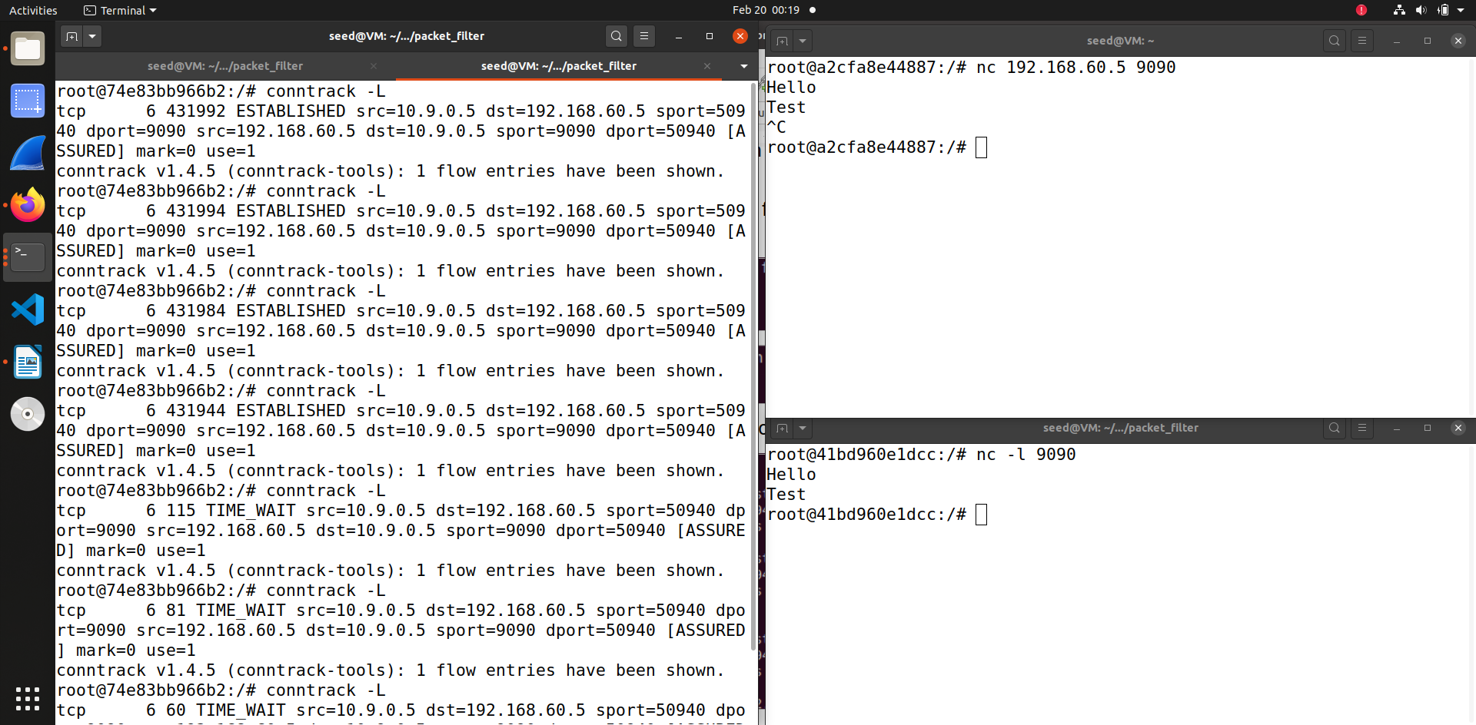

In this experiment first on 192.168.60.5 I started the netcat server , and then I send out TCP packets from 10.9.0.5

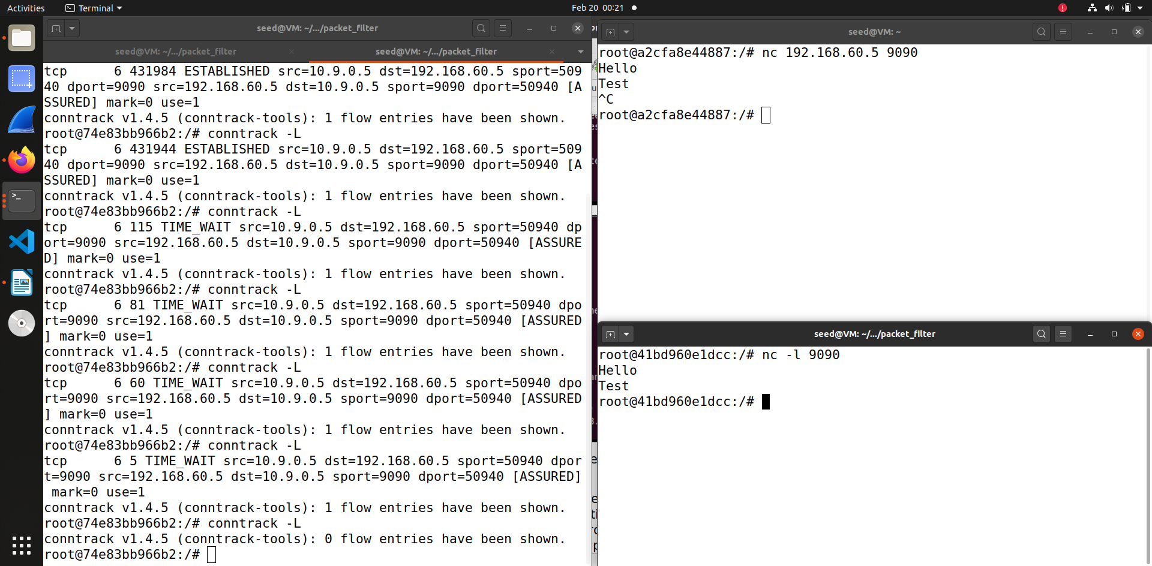

For this experiment the entry was kept for a longtime. After I stopped the connection the entry was still visible . For this experiment the entry was visible for the longest time, it was about 240 seconds or so for me.

**Task 3.B: Setting Up a Stateful Firewall**

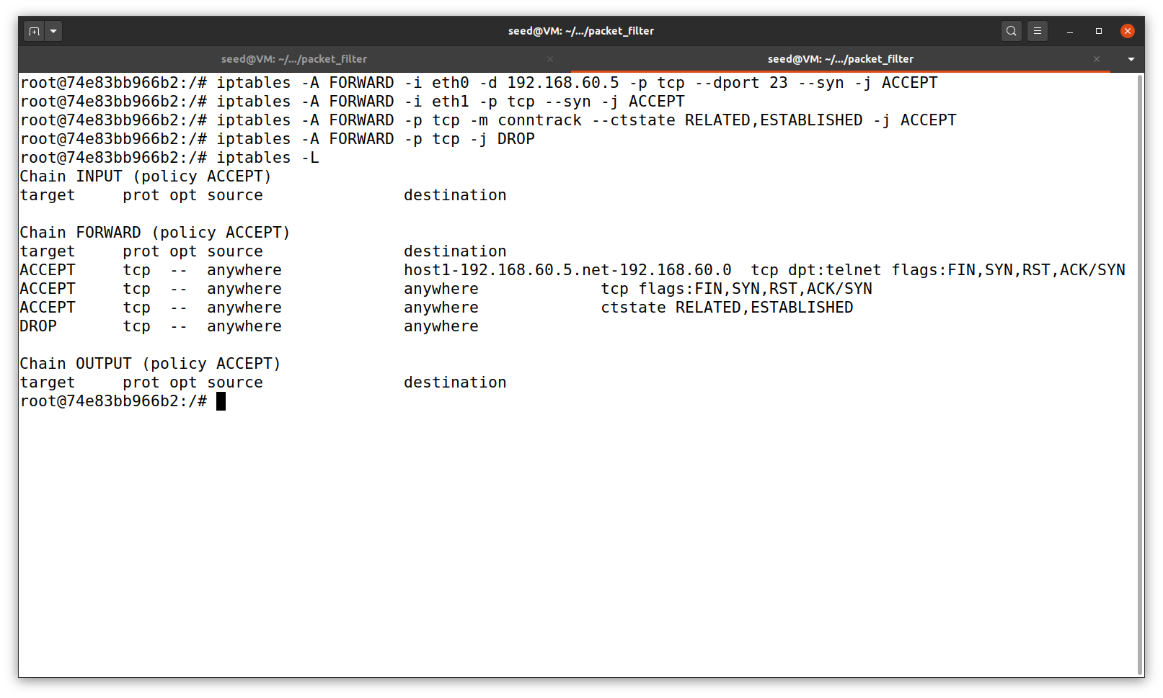In this sub task we set up firewall based on the conntrack module. We allow TCP packets belonging to 192.168.60.5 to pass through, accept the incoming SYN packets allow internal hosts to visit any external server and set default policy on FORWARD to drop everything.

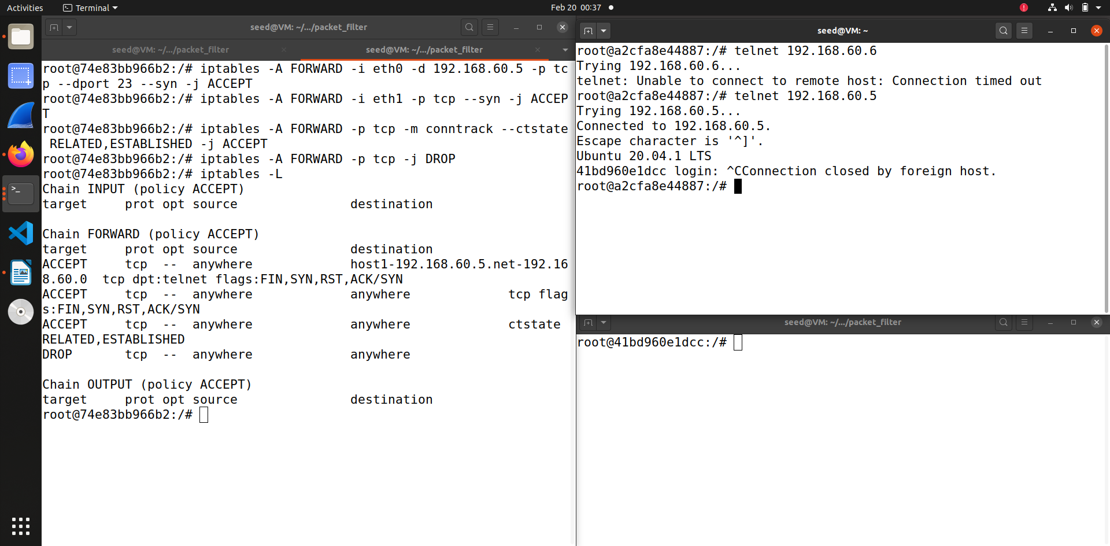When we try to telnet 192.168.60.6 it doesn’t work from external host A. But when we do the same for 192.168.60.5 we are able to connect it.

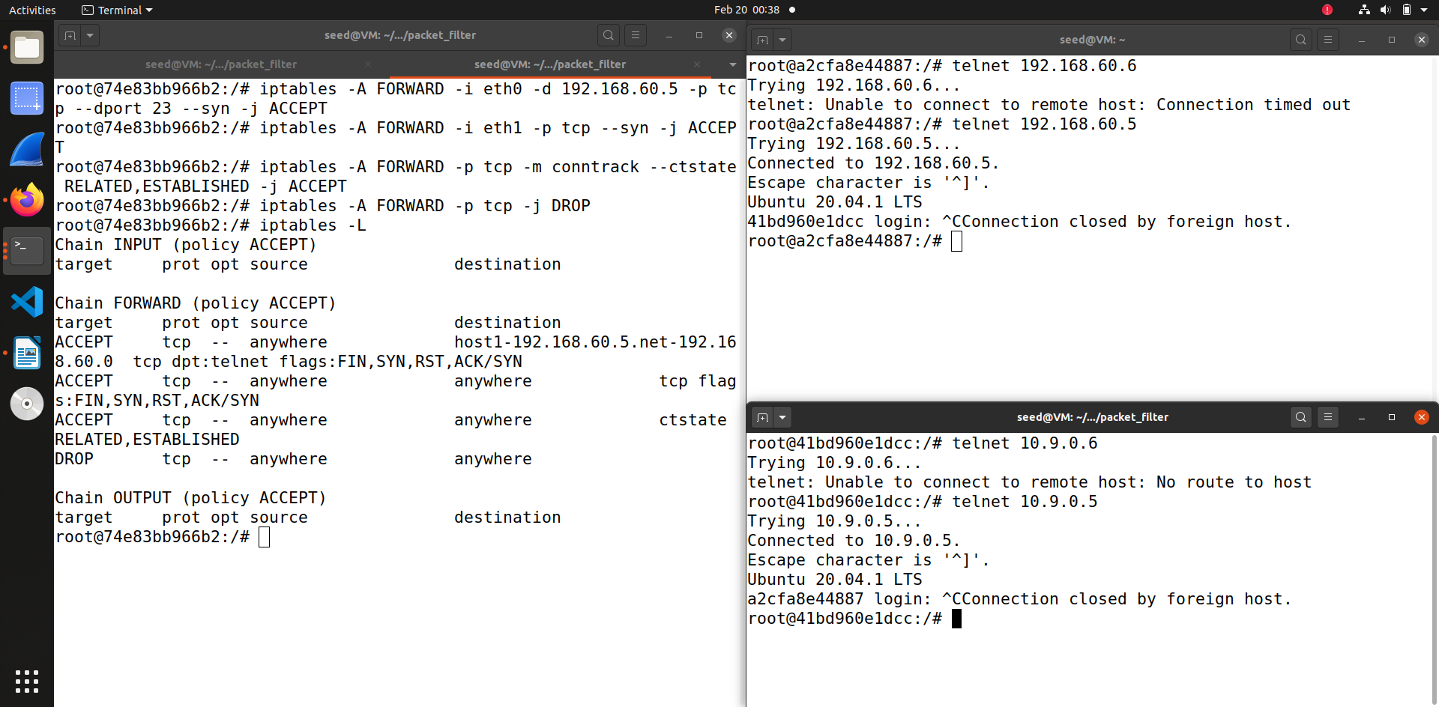

Similarly when we try to connect to 10.9.0.6 that doesn’t work, and when we try to connect 10.9.0.5 which the external host it is possible, this shows internal hosts can visit external hosts.

This task also asks questions – can this be done without connection tracking?

I think if we did without it, then it would be hard as there would be uncertainties to understand which packet belongs to existing connection, is it one from external server to internal one or vise versa. This is also advantageous as it doesn’t need extra resources. We can achieve this without second step by dropping the SYN packet for external servers.

**Task 4**

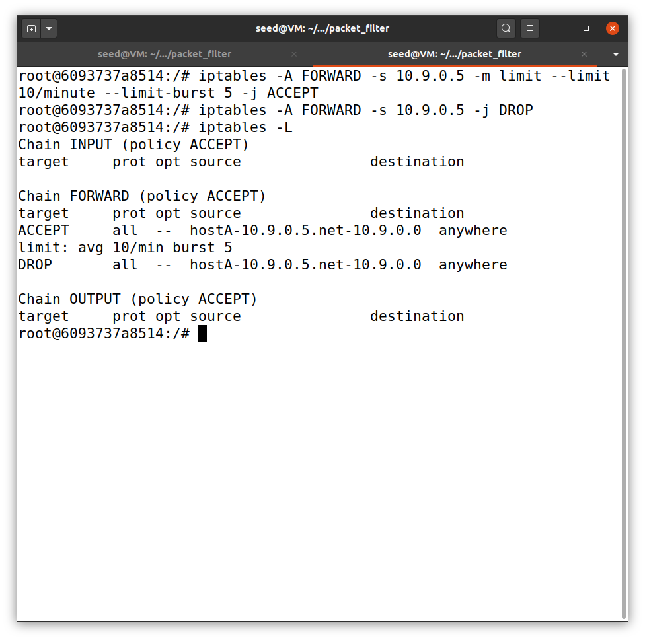In this task we use the limit module to limit how many packets from 10.9.0.5 are allowed to get into internal network. So in this task I have set rule to limit the traffic to average 10/min with a burst of 5.

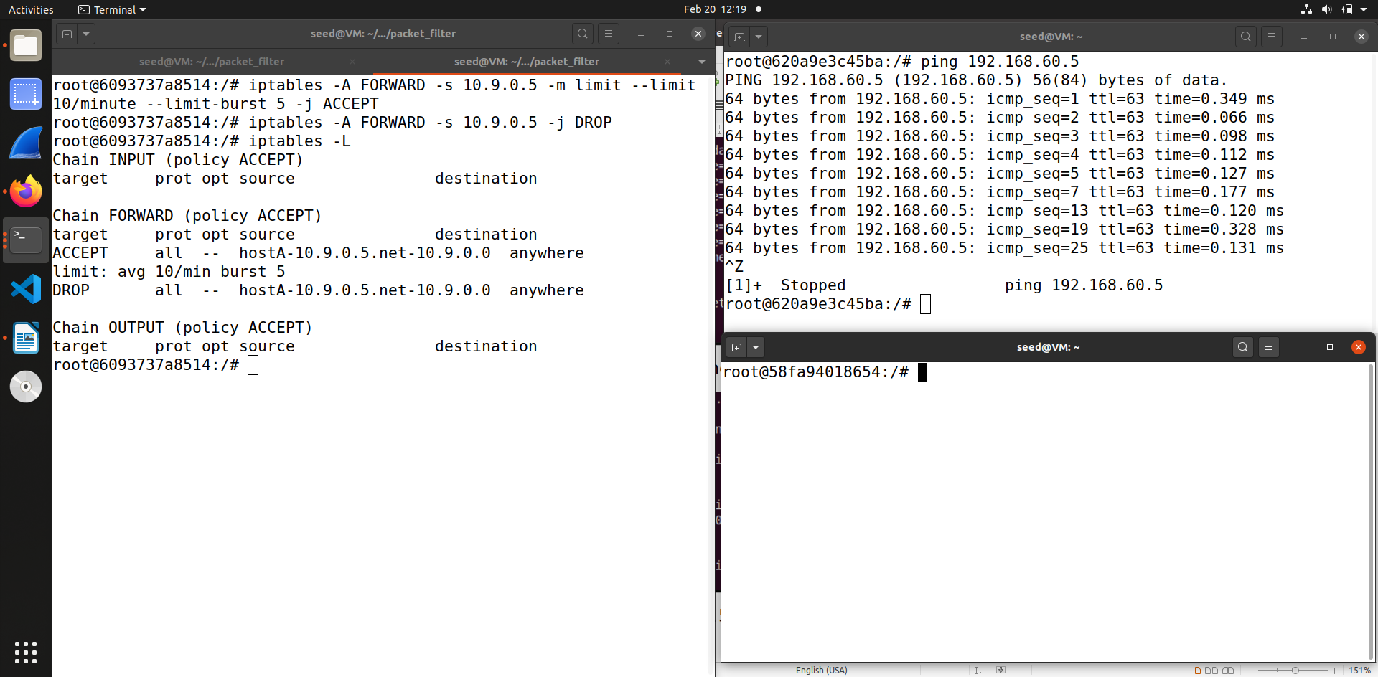

So when I ping 192.168.60.5 from 10.9.0.5, I get the limit traffic.

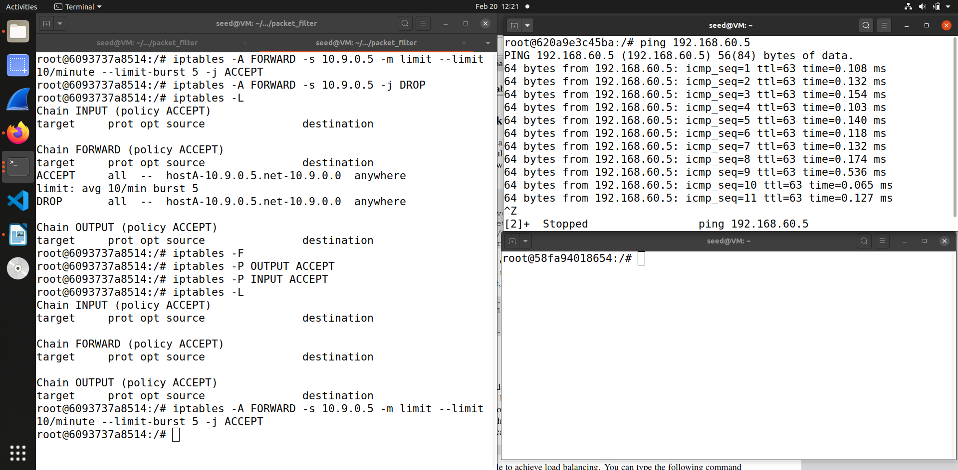When I cleared the the iptables and only run with the first rule you can see that the limit traffic doesn’t work, and it send packets every second. When we add the second rule then only packet is accepted after every 6 seconds and other packets in between are dropped.

**Task 5**

In this task we use load balancing for 3 UDP servers running in internal network

**Using the nth mode(round robin) -**

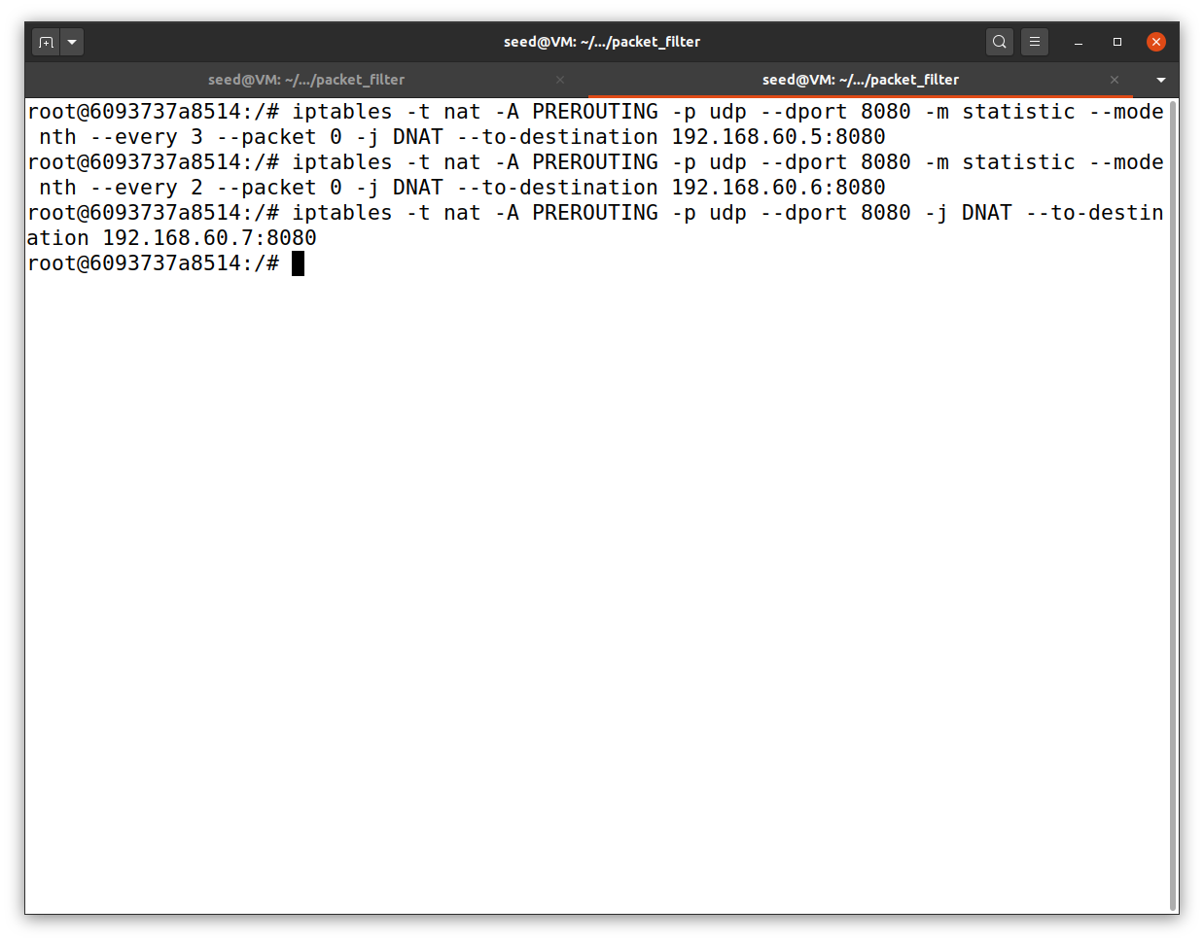So in this we take the first packet out of every 3 packets and send to 192.168.60.5, then out of the remaining 2 packet we send out first to 192.168.60.6 and then the last one goes to 192.168.60.7

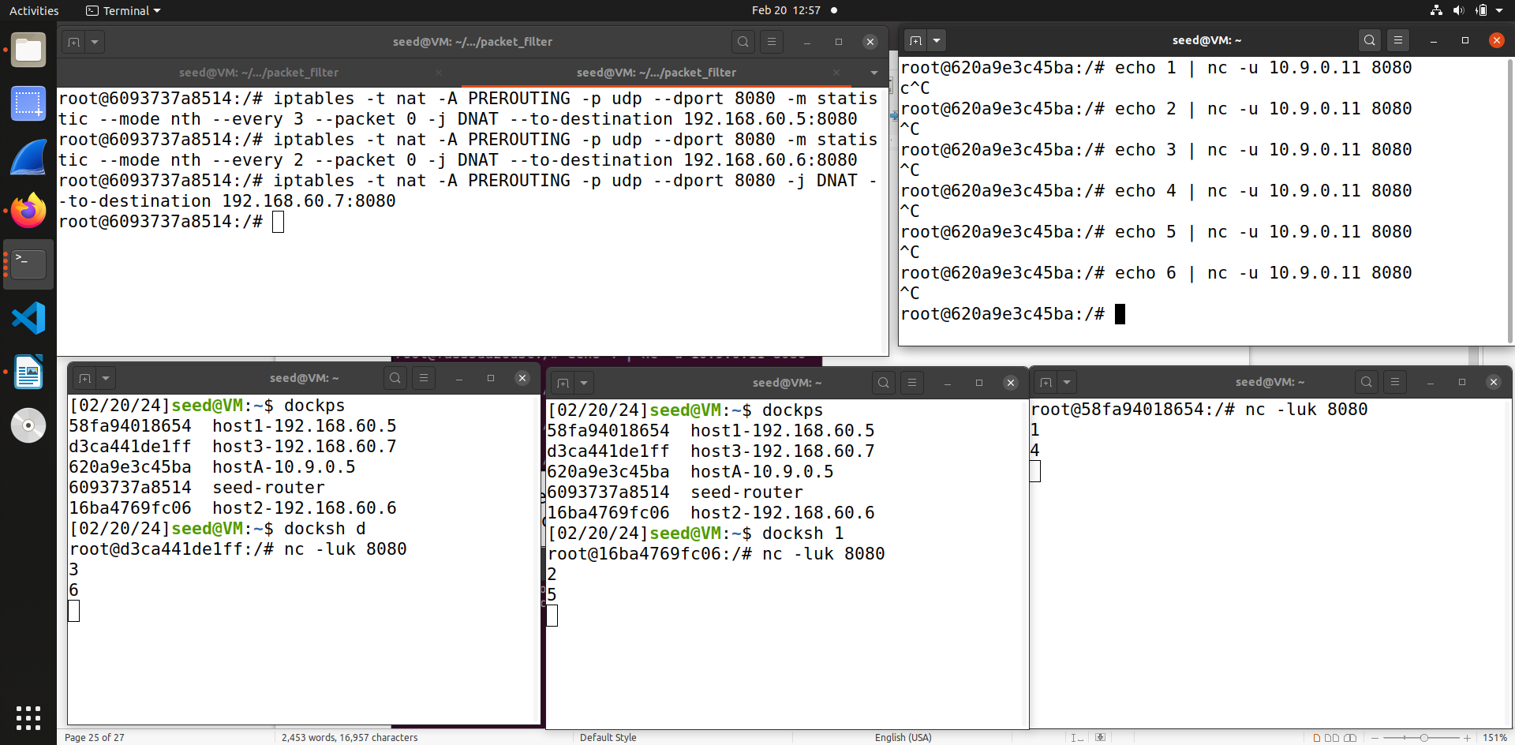So from the screenshot you can see that equal distribution of packets is done .

**Using the random mode -**

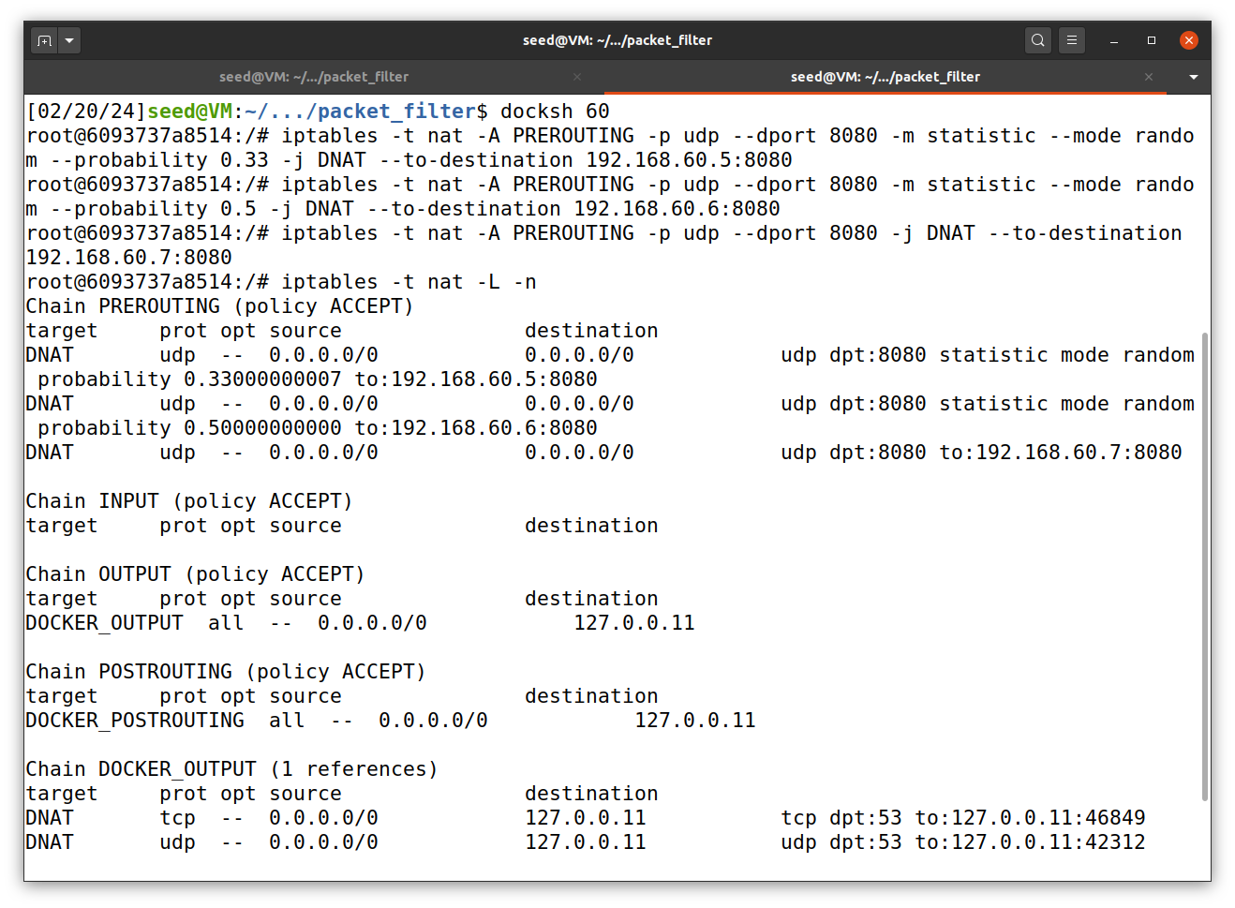In this mode, I have set the following rules for 192.168.60.5 (100/3 =0.33) so it get’s a probability of 33% , then 192.168.60.6 (50/2=0.5) which means 50% and then the remaining the packets goes to 192.168.60.7. But this mode is random so the division won’t be equal.

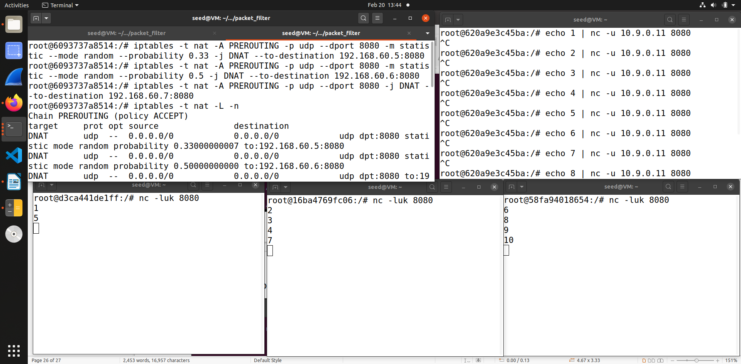Similar to the previous round robin task we set the 3 udp servers and then using netcat send packets to the servers. I have send 10 packets to view the distribution

Thus these are the two ways of doing the load balancing using the statistics module.